**UNIT 3 & 4 CHEM Name: _______________**

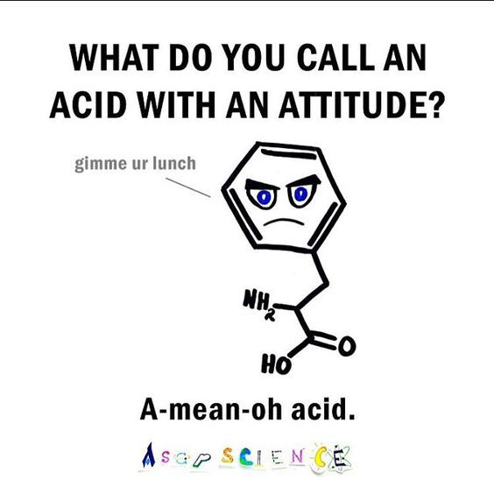

**TOPIC 5 ½:**   
ORGANIC CHEM II

Syllabus dot-points

**Science Understanding:**

*Identification of Unknowns*

* empirical and molecular formulae can be determined by calculation and the structure of an organic compound established from the chemical reactions they undergo, and other analytical data

*Polymers*

* addition reactions can be used to produce polymers, including polyethene and polytetrafluoroethene
* the structure of an addition polymer can be predicted from its monomer and the structure of an addition polymer can be used to predict the monomer from which it was derived
* condensation reactions can be used to produce polymers, including polyamides and polyesters
* the structure of a condensation polymer can be predicted and drawn from its monomer(s) and the structure of a condensation polymer can be used to predict the monomer(s) from which it was derived
* industry produces a vast range of plastics, including addition polymers (polyethene, polytetrafluoroethene) and condensation polymers (nylon and polyethylene terephthalate [PET]) which have different properties and uses

*Amino Acids*

* α-amino acids can be represented using a generalised structure
* the characteristic properties of α-amino acids include the formation of zwitterions and the ability to react to form amide (peptide) bonds through condensation reactions
* α-amino acids undergo condensation reactions to form polypeptides (proteins) in which the α-amino acid monomers are joined by peptide bonds

*Proteins*

* the sequence of α-amino acids in a protein is called its primary structure
* secondary structures of proteins, (α-helix and β-pleated sheets) result from hydrogen bonding between amide and carbonyl functional groups; hydrogen bonding between amide and carbonyl functional groups within a peptide chain leads to α-helix structures while hydrogen bonding between adjacent polypeptide chains leads to β -pleated sheets
* the tertiary structure of a protein (the overall three-dimensional shape) is a result of folding due to interactions between the side chains of the α-amino acid in the polypeptide, including disulfide bridges, hydrogen bonding, dipole-dipole interactions, dispersion forces and ionic interactions

**Science as a Human Endeavour:**

* The Protein Data Bank (PDB) houses an international repository of structural data of proteins. The information is accessed and contributed to by scientists worldwide. The function of a protein is closely linked to its structure.

**Revision – Organic Reactions FlowchartEmpirical Formula**

The empirical formula is the **simplest whole-number ratio of moles of elements in a compound**.

* In hydrogen peroxide (H2O2), there is 1 H for every 1 O. The empirical formula is **HO**.
* In hexane (C6H14), there are 3 C’s for every 7 O’s. The empirical formula is **C3H7.**
* In benzene (C6H6), there is 1 C for every 1 H. The empirical formula is **CH**.

Some molecular formulas cannot be simplified any further. Methanol (CH3OH) has an empirical formula of **CH4O**, which is the same as its molecular formula.

The empirical formulas of compounds can be calculated. In each case, you will need to find the **number of moles of each element**, and then perform a ratio of those numbers of moles.

**Empirical formula from percentage composition**

**Example:**

A compound is found to contain 64.80% carbon, 13.62% hydrogen and 21.58% oxygen by weight. What is the empirical formula for this compound?

**Process:**

* Assume there is 100 g of sample. ∴ you have 64.80 **grams** of carbon, 13.62 **grams** of hydrogen, etc
* Find the moles of each element
* Find the ratio of elements by dividing by the smallest number of moles

**Solution:**

|  |  |  |  |
| --- | --- | --- | --- |
|  | **C** | **H** | **O** |
| **Mass** (in 100 g) | 64.80 g | 13.62 g | 21.58 g |
| **Moles** *(n=m/M)* | $$\frac{64.80}{12.01}=5.40 mol$$ | $$\frac{13.62}{1.008}=13.5 mol$$ | $$\frac{21.58}{16.00}=1.35 mol$$ |
| **Mole ratio** | $$\frac{5.40}{1.35}=4$$ | $$\frac{13.5}{1.35}=10$$ | $$\frac{1.35}{1.35}=1$$ |

**The empirical formula is C4H10O**

**Complications with mole ratios:**

Sometimes the mole ratio you achieve in the last step will give a number that is not whole, such as the below example. In this case, multiply by whichever number will give a whole number ratio (e.g. K2Cr2O7)

|  |  |  |  |
| --- | --- | --- | --- |
|  | **K** | **Cr** | **O** |
| **Mole ratio** | 1.00 | 1.00 | 3.50 |
| **(x2)** | 2.00 | 2.00 | 7.00 |

**Q1:**

A compound contains 57.54% C, 3.45% H, and 39.01% F. What is its empirical formula?

**[ C7H5F3 ]**

**Q2:**

Halothane is an anesthetic that is 12.17% C, 0.51% H, 40.48% Br, 17.96% Cℓ and 28.87% F by mass. Calculate the empirical formula.

**[ C2HBrCℓF3 ]**

**Q3:**

Chemical analysis shows that citric acid contains 37.51% C, 4.20% H, and 58.29% O. What is the empirical formula?

**[ C6H8O7 ]**

**Empirical formula by combustion - Hydrocarbons**

When you combust a hydrocarbon it produces carbon dioxide and water.

All of the **carbon** in the original molecule ends up being part of the **carbon dioxide**.   
If you know the moles of **CO2**, you could figure out the moles of **carbon** in the original molecule.

All of the **hydrogen** in the original molecule ends up being part of the **water**.   
If you know the moles of **H2O**, you could figure out the moles of **hydrogen** in the original molecule.

**Example:**

A 1.50 g sample of **hydrocarbon** undergoes complete combustion to produce 4.40 g of CO2 and 2.70 g of H2O. What is the empirical formula of the compound? **(Remember: hydrocarbons only include C and H)**

**Process:**

* Find n(CO2), and from that find n(C)
* Find n(H2O), and from that find n(H)
* Find the ratio of C to H

**Solution:**

|  |  |
| --- | --- |
| $$n\left({CO}_{2}\right)=\frac{m}{M} \\ =\frac{4.40}{44.01} \\ =0.100 mol \\ n\left(C\right)=n\left({CO}_{2}\right) \\ =0.100 mol$$ | $$n\left(H_{2}O\right)=\frac{m}{M} \\ =\frac{2.70}{18.016} \\ =0.150 mol \\ n\left(H\right)=2×n\left(H_{2}O\right) \\ =0.300 mol$$ |

**Mole ratio:**

|  |  |
| --- | --- |
| **C** | **H** |
| $$\frac{0.100}{0.100}=1$$ | $$\frac{0.300}{0.100}=1$$ |

**Empirical formula is CH3**

**Q4:**

A 0.250 g sample of **hydrocarbon** undergoes complete combustion to produce 0.845 g of CO2 and 0.173 g of H2O. What is the empirical formula of this compound?

**[ CH ]**

**Q5:**

Naphthalene is a **hydrocarbon** that is used for moth balls. A sample was burned in pure oxygen to produce 1.100 g of carbon dioxide and 0.1798 g of water. Calculate the empirical formula of the compound.

**[ C5H4 ]**

**Empirical formula by combustion – Compounds with C, H and O**

The previous examples were hydrocarbons (C and H only), but many important organic molecules also include oxygen. e.g. methanol (CH3OH) and ethanol (CH3CH2OH). The empirical formulas of these compounds can also be found if you know the amount of CO2 and H2O formed, along with the mass of the original sample.

The general process is:

* Find mass of carbon… m(CO2) → n(CO2) → n(C) → **m(C)**
* Find mass of hydrogen… m(H2O) → n(H2O) → n(H) → **m(H)**
* Calculate mass of oxygen… m(O) = m(sample) – m(C) – m(H)
* Calculate moles of oxygen
* Find the mole ratio

**Do not try to find n(O) using the n(CO2) or the n(H2O)!**

**Example:**

12.915 g of a biochemical substance containing only carbon, hydrogen, and oxygen was burned in an atmosphere of excess oxygen. Subsequent analysis of the gaseous result yielded 18.942 g carbon dioxide and7.749 g of water.

Determine the empirical formula of the substance.

**Solution:**

**Mole ratio:**

|  |  |  |
| --- | --- | --- |
| **C** | **H** | **O** |
| $$\frac{0.430}{0.430}=1$$ | $$\frac{0.860}{0.430}=2$$ | $$\frac{0.430}{0.430}=1$$ |

**Empirical formula is CH2O**

|  |  |
| --- | --- |
|  |  |
|  |  |

**Q6:**

A 4.24 g sample of carboxylic acid (composed of only C, H and O) is burned. The reaction produces 6.21 g of carbon dioxide and 2.54 g of water. Determine the empirical formula.

**[ CH2O ]**

**Q7:**

A 3.87 mg sample of ascorbic acid (containing C, H and O only) produces 5.80 mg CO2 and 1.58 mg H2O on combustion. What is the empirical formula of ascorbic acid?

**[ C3H4O3 ]**

**Empirical formula by combustion – Adding in other elements**

Remember, you want to find the ratio of **moles**. Look for pathways that will lead you to a mole ratio.

**Q8:** A sample of a compound containing carbon, hydrogen and nitrogen only was burnt completely in oxygen. 26.4 g of CO2, 6.30 g of H2O and 4.60 g of NO2 were produced. What is the empirical formula of the compound?

**[ C6H7N ]**

**Q9:** A compound that contains only C, H and Cℓ was studied by combustion analysis. A sample with a mass of 0.367 g was combusted in oxygen to produce 0.659 g of CO2 and 0.0892 g of H2O. What is the empirical formula?

**[ C3H2Cℓ ]**

**Q10:** A 2.52 g sample of a compound containing **carbon, hydrogen, nitrogen, oxygen and sulfur** was burned in excess oxygen gas to yield 4.36 g of CO2, 0.892 g of H2O, 1.583 g of SO3 and 0.910 g of NO2. Calculate the empirical formula of the compound.

**[ C5H5NOS ]**

**Empirical formula by combustion – Different sample sizes**

Consider the following problem:

Lysine is an amino acid which has the following elemental composition: C, H, O, N. In one experiment, 2.175 g of lysine was combusted to produce 3.94 g of CO2 and 1.89 g H2O as the only carbon and hydrogen-containing compounds.

**In a separate experiment, 1.873 g of lysine was burned to produce 1.18 g of NO2**. Determine the empirical formula.

This question is complicated because the information about nitrogen comes from a **different sample size**.

This means we cannot compare the moles of C and H (from the first sample) with the moles of N (from the second sample). We also cannot easily do m(O) = m(sample) – m(C) – m(H) – m(N), because the mass of nitrogen calculated wouldn’t be correct for the larger 2.175 g sample.

There are two approaches to solving empirical formula problems which have multiple samples.

**APPROACH #1: Calculating the percentage of each element from each sample.**

* Find the mass of carbon in Sample #1, then convert that to %C %C = m(C) / m(sample 1) x 100
* Find the mass of hydrogen in Sample #1, then convert that to %H %H = m(H) / m(sample 1) x 100
* Find the mass of nitrogen in **Sample #2**, then convert that to %N %N = m(N) / **m(sample 2)** x 100
* Find the %O. %O = 100 – (%C + %H + %N)
* Work out the empirical formula using the four percentages.

**APPROACH #2: Adjust the data for sample #2 to make it consistent with the data for sample #1**

In this case, a 2.175 g sample would have produced more NO2 than a 1.873 g sample of the original compound did.

By performing the following calculation, we can figure out that a 2.175 g sample would have produced 1.37 g of NO2.

This means we could find m(C), m(H) and m(N) for **sample #1 only**. They are all from the same sample mass, so m(O) can be calculated through the usual method.

From experience, this method is **faster** and preferred by people with good mathematical ability, but those who are weaker at calculations often make more mistakes. Approach #1 is safer, but takes longer to complete.

**Q11:** Complete the question described in the example on the left-hand page. Remember, the sample contains carbon, hydrogen, nitrogen and oxygen only.

**[ C3H7NO ]**

**Q2:** A compound of carbon, hydrogen, nitrogen and oxygen was analysed as follows:

First, a 1.342 g sample was combusted and 2.109 g of carbon dioxide and 0.288 g of water were collected.

A second sample (1.061 g) was treated to convert all the nitrogen into ammonia, which was analysed by titration and found to be 0.01263 mol. Calculate the empirical formula of the compound.

**[ C3H2NO2 ]**

**Q12:** A compound containing carbon, hydrogen, nitrogen and oxygen was analysed as follows.

First a 1.476 g sample was burnt and 2.320 g of CO2 and 0.3168 g of H2O were formed. A second sample (1.167 g) was treated to convert all the nitrogen into ammonia. The ammonia was titrated and found to be 0.01389 mol.

Calculate the empirical formula of the compound.

**Empirical formula → Molecular Formula**

If you know the **empirical formula** and have information about the **molecular weight** then you can determine the **molecular formula** of the compound.

**Example 1:** You have determined that a compound has an empirical formula of **C5H10O4**.   
The molecular weight is approximately **134 g mol-1**. What is the molecular formula?

**Solution:**

M(C5H10O4) = **134.13 g mol-1**

This matches the molecular weight. ∴ the molecular formula is **_________________**

**Example 2:** You have determined that a compound has an empirical formula of **CH3.**   
The molecular weight is **30 g mol-1**. What is the molecular formula?

**Solution:**

M(CH3) = **15 g mol-1**

The molecular weight is 2x M(CH3). ∴ the molecular formula is **_________________**

***Practice:***

|  |  |  |  |  |
| --- | --- | --- | --- | --- |
| **Empirical formula** | **Empirical formula weight** | **Molecular formula weight** | **Ratio… MFW/EFW =** | **Molecular formula** |
| C2OH4 |  | 88 |  |  |
| C4H4O |  | 136 |  |  |
| CFBrO |  | 254.7 |  |  |
| C2H8N |  | 46 |  |  |

Sometimes the question will not tell you the molecular weight directly and you will have to calculate it.

Over the last two years you have been using the following formulas:

**n = m / M moles = mass / molar mass**

**m = n x M mass = moles x molar mass**

If you are provided with information about the **moles** and the **mass**, you could also rearrange this formula to find **molar mass (molecular weight)**. Complete the rearranged equation below…

**M =**

This will allow you to calculate the molecular weight in situations where you do not know the molecular formula (only the empirical formula). Expect this as a follow-up question in extended empirical formula calculations.

**Q13:** Caffeine, a stimulant found in coffee, chocolate and tea, has a percentage composition of 49.48% carbon, 5.15% hydrogen, 28.87% nitrogen and 16.49% oxygen. If 0.00173 mol of caffeine has a mass of 0.334 g, what is its molecular formula?

**[ C8H10N4O2 ]**

A more advanced version of this calculation may involve being provided with information about gas volumes, temperature and pressures. If you know the pressure (P), volume (V) and temperature (T) of a gas then you can find the moles of gas. The equation is…

**P V = n R T** or, rearranged to find moles… **n = (PV) / (RT)**

In these equations:

Pressure is in kilopascals (kPa) ***To change atmospheres to kPa, multiply by 101.3***

Volume is in litres (L)

Temperature is in Kelvin (K) ***To change °C to Kelvin, add 273.15***

R is a constant given on your data sheet. R = 8.314.

**Example:** You have determined that a compound has an empirical formula of **C3H4O3.**   
A 3.50 g sample of this compound was vapourised and occupies a volume of 460 mL at 1.05 atm and 25 °C. What is the molecular formula of the gas?

**Solution:**

P = 1.05 x 101.3 = 106.365 kPa

V = 460 / 1000 = 0.460 L

T = 25 + 273.15 = 298.15

n(sample) = PV/RT

= (106.365 x 0.460) / (8.314 x 298.15)

= 0.01974 mol

M(sample) = m / n

= 3.50 / 0.01974

= 177 g mol-1

M(C3H4O3) = 88 g mol-1 ∴ the molecular formula is **_________________**

**Q14:**

A 3.990 g sample of an organic compound was vapourised and collected at 210.0 °C and 101.3 kPa pressure, it was found to occupy a volume of 2.680 L. Find the molecular weight of the compound.

**[ 58.99 g mol-1 ]**

**Q15:** A forensicchemist analysed some tablets suspected of being a popular steroid. He determined that the substance in the tablet contains only carbon, hydrogen and oxygen, and has a molar mass of 300.14 g mol-1. When a 1.200 g sample was combusted, 3.516 g of CO2 and 1.007 g of H2O were collected. What is the molecular formula of the substance?

**[ C20H28O2 ]**

**Q16:** A chemist was sent an unknown organic compound for analysis. Qualitative tests indicated it contained only carbon, hydrogen and oxygen. A sample of mass 0.0155 g was heated in pure oxygen to produce 0.0220 g of carbon dioxide and 0.0135 g of water. A further 0.490 g sample when vapourised completely at 200.0 °C and 101.3 kPa occupied 0.306 L. Determine the empirical and molecular formulae.

**[ CH3O, C2H6O2 ]**

**Q17.** Qualitative analysis of an organic compound showed that it contained carbon, hydrogen and oxygen only.

When 0.392 g of this sample was burnt in excess oxygen it produced 0.320 g of water and 547 mL of carbon dioxide at 100.0°C and 101.3 kPa pressure.

When another 0.392 of the sample was heated to 250.0°C, the vaporised sample was found to create a pressure of 194 kPa in a 1.00 × 102 mL container.

(a)  Determine the empirical formula of the compound.

(b)  Determine the molecular formula of the compound.

(c) When this compound was reacted with methanol it was found to produce a liquid that smelt like apples.

(i)  Draw the structural formula of the compound.

(ii)  Name the product formed when it reacts with methanol.

**[ (a) C2H4O; (b) C4H8O2; (c) butanoic acid, methyl butanoate ]**

**Q18.**  When 3.990 g of an organic compound, containing only C, H and N, was burnt in excess oxygen, 8.927 g of carbon dioxide, 5.478 g of water vapour and 3.111 g of nitrogen dioxide were produced.

1. Determine the empirical formula of the compound.

When a further 3.990 g sample of the compound was vapourised and collected at 210.0 °C and 101.3 kPa pressure, it was found to occupy a volume of 2.680 L.

(b)  Calculate the molecular formula of the compound.

(c) Draw a possible structural formula of compound and give its IUPAC name.

**[ (a) C3H9N; (b) C3H9N; (c) propanamine ]**

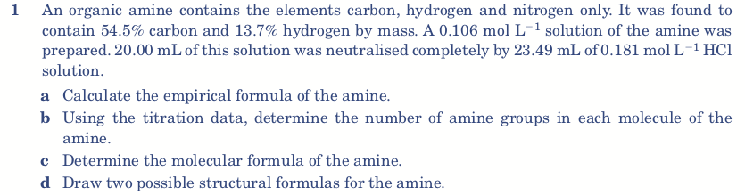

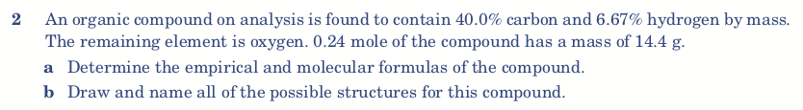

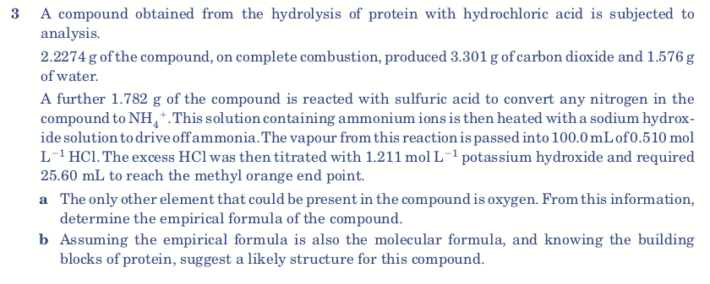

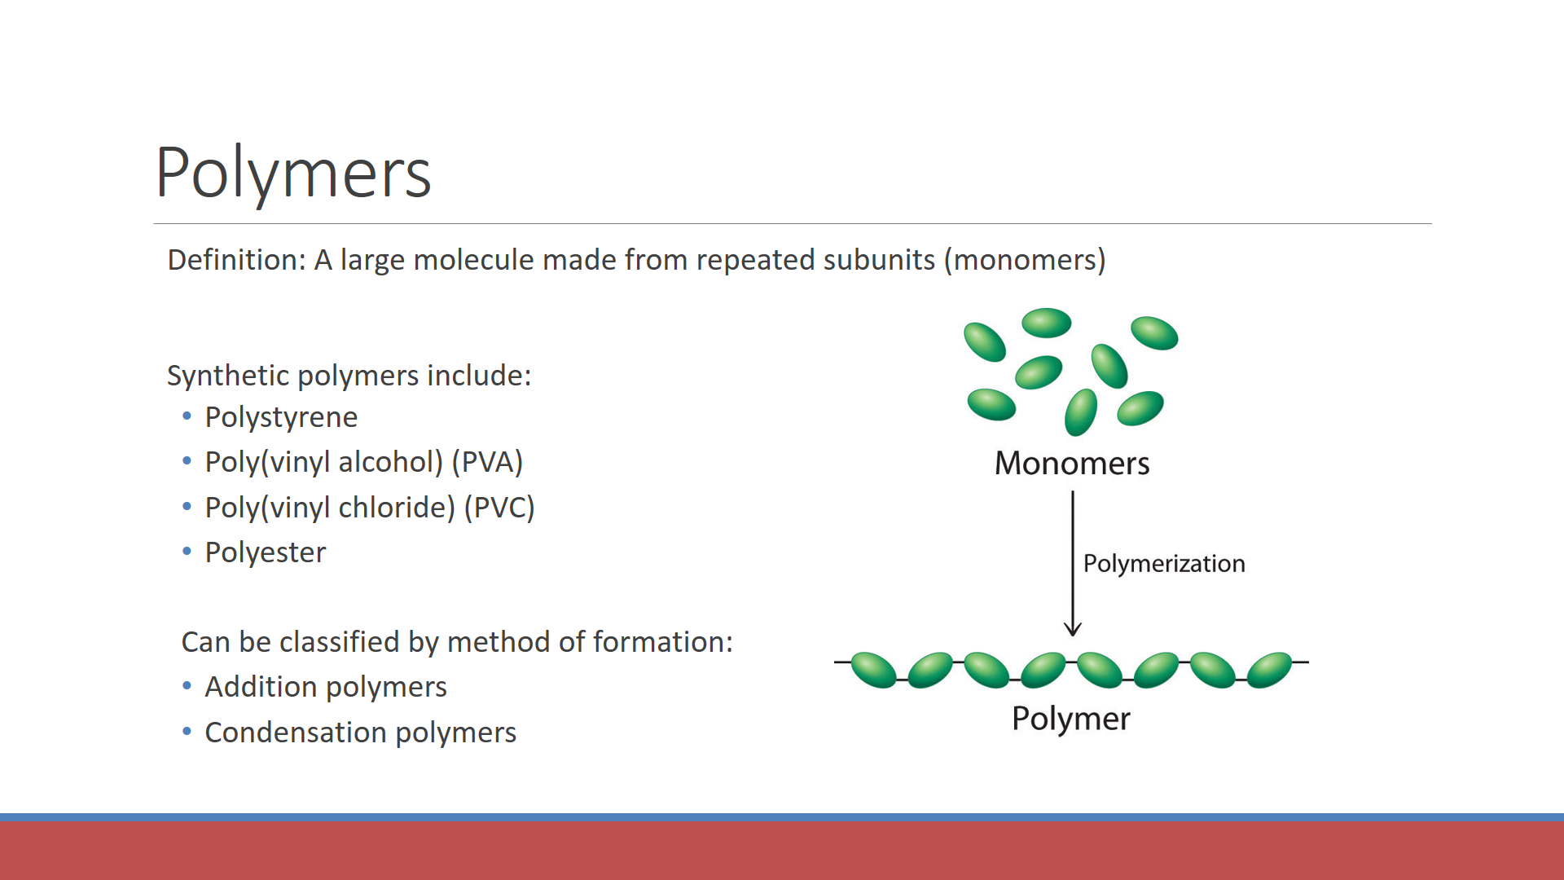

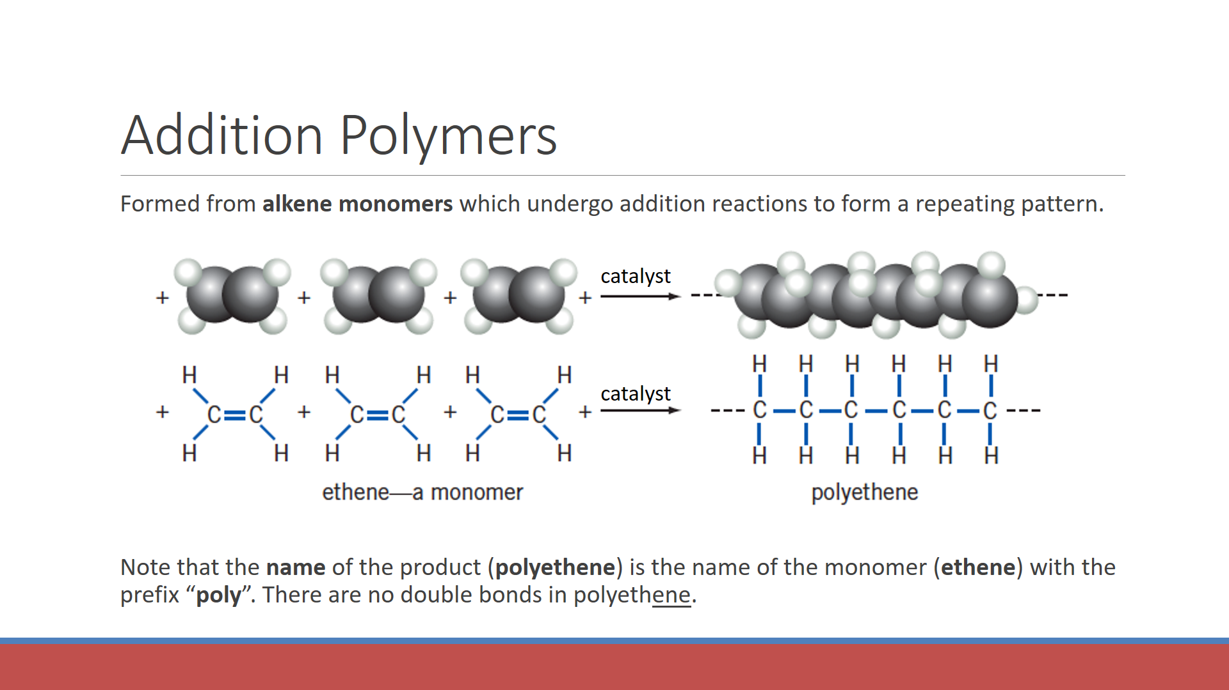

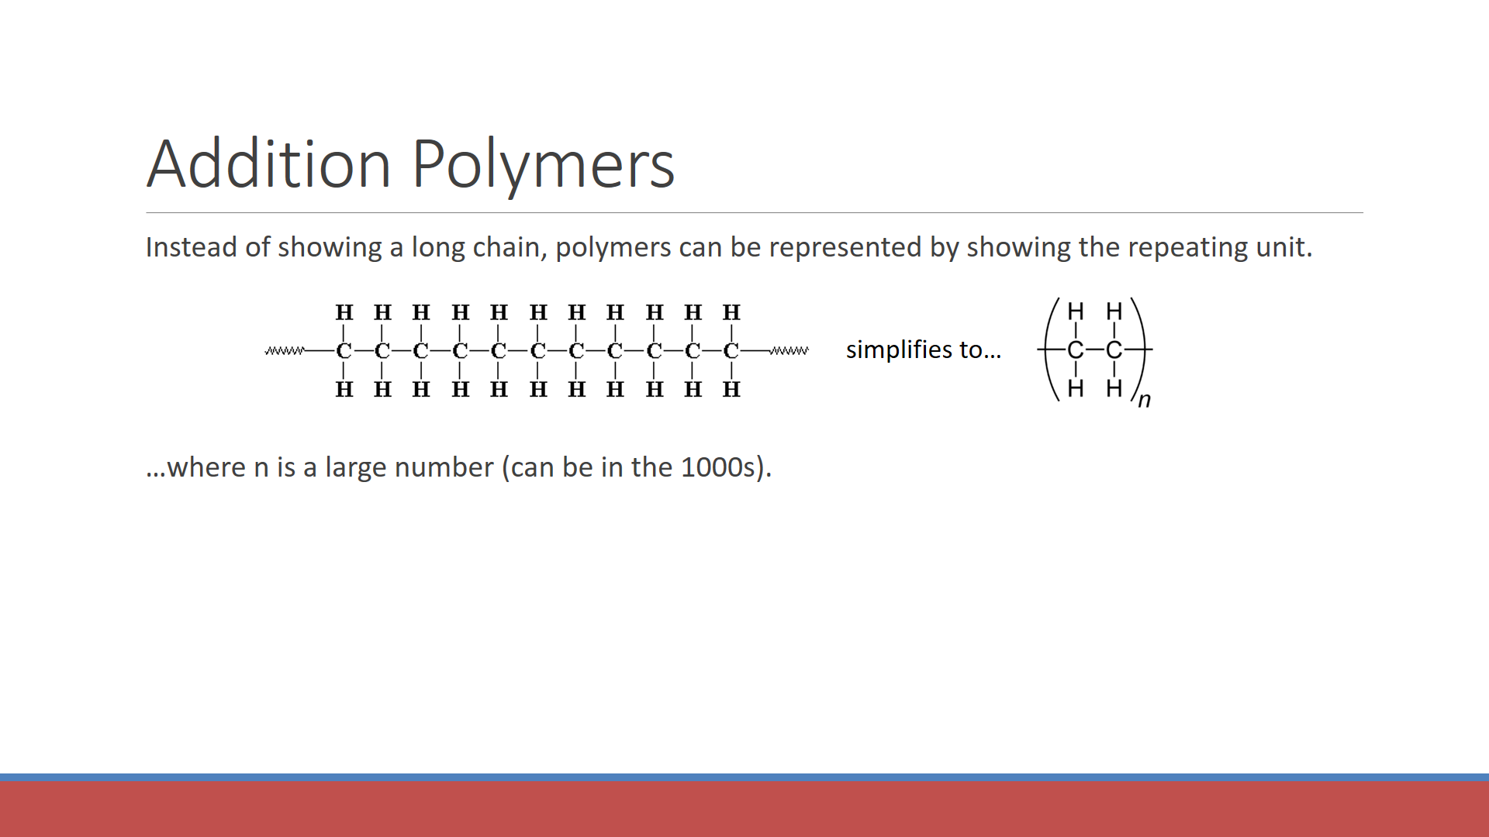

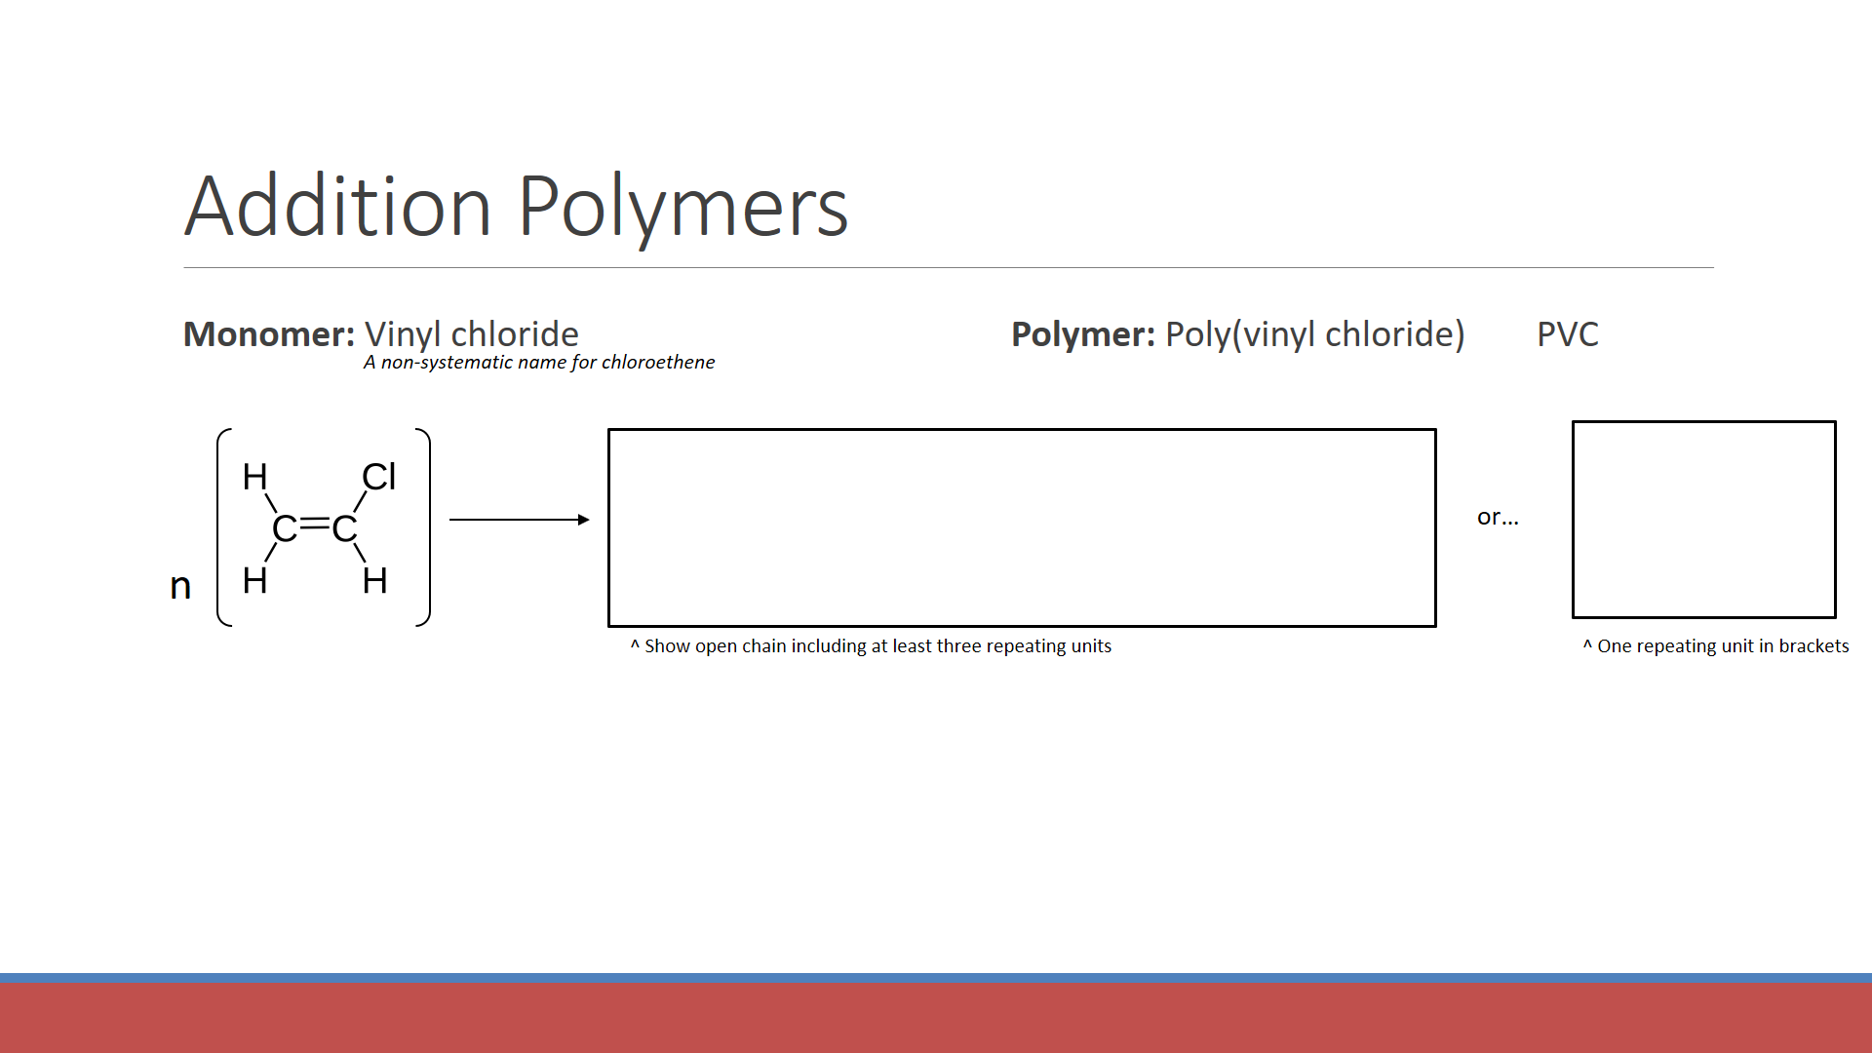

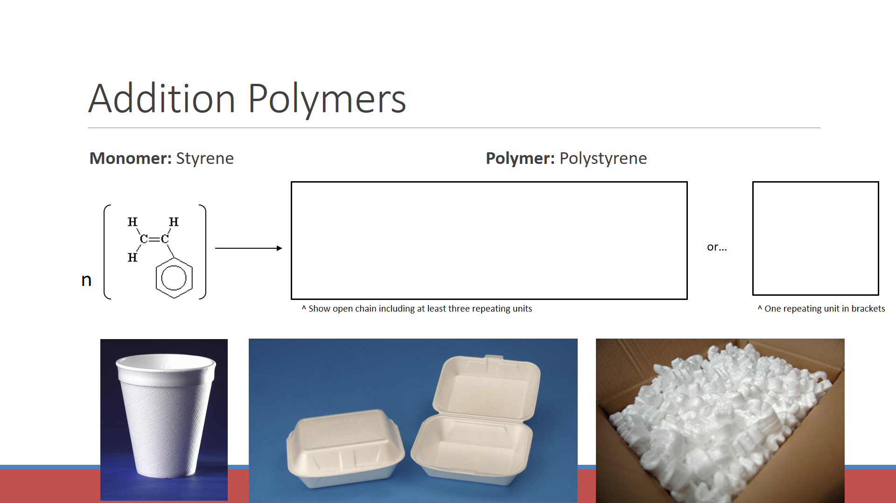

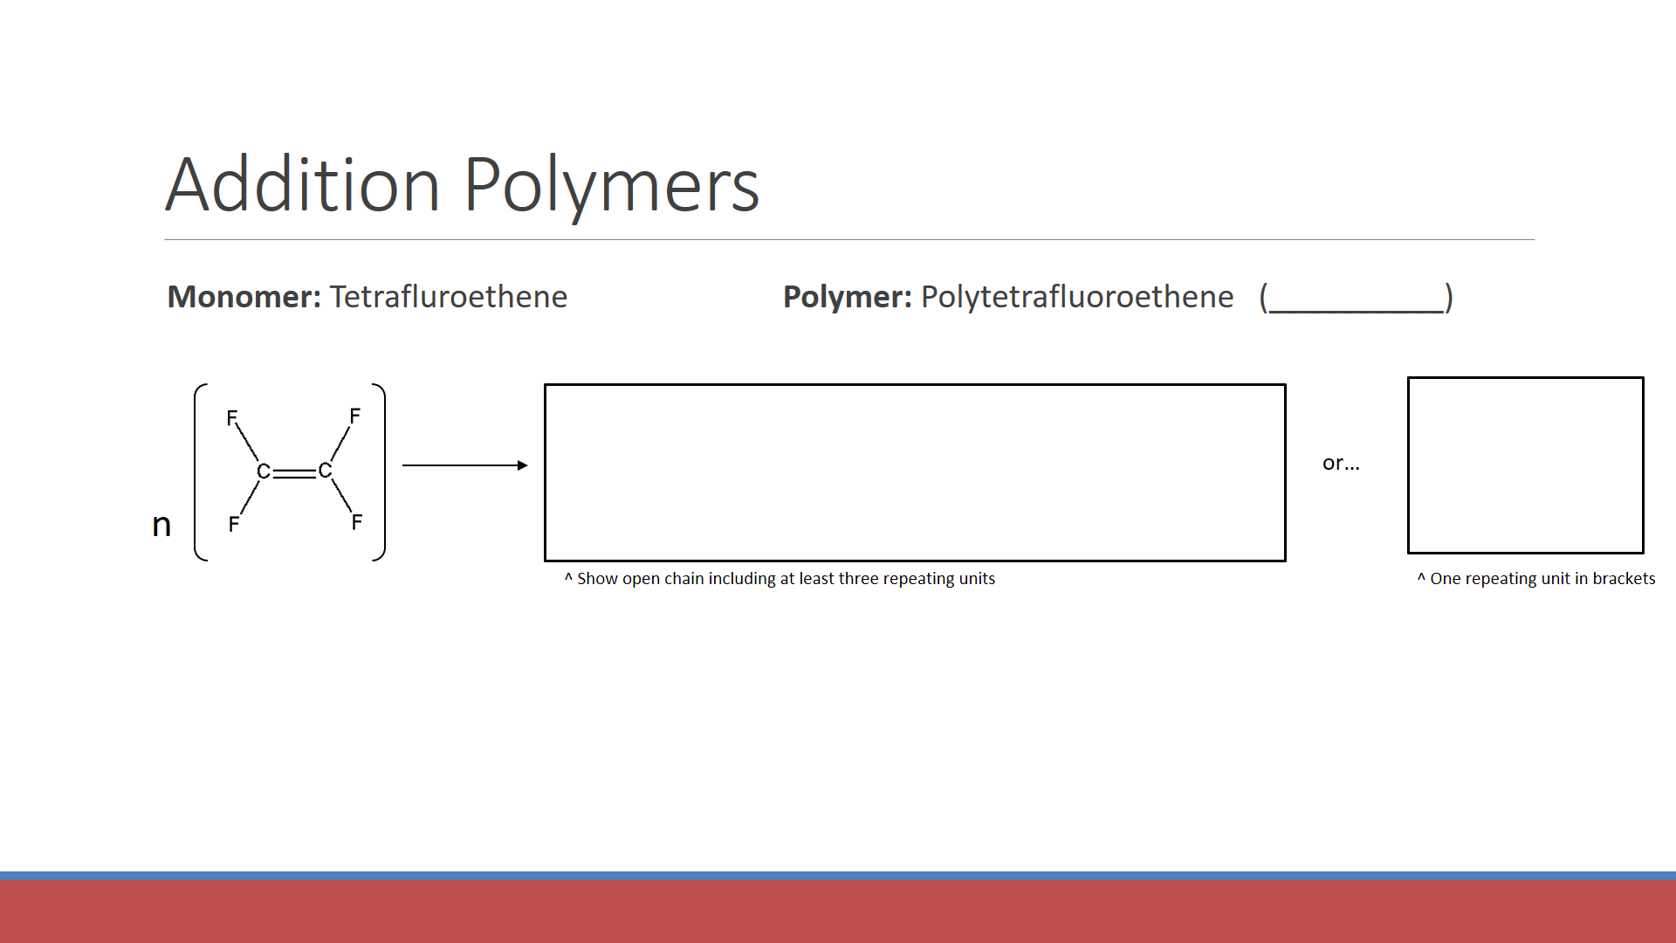

**Working backwards:**

* Identify the repeating unit
* Figure out what alkene monomer would have been used to prepare that repeating unit

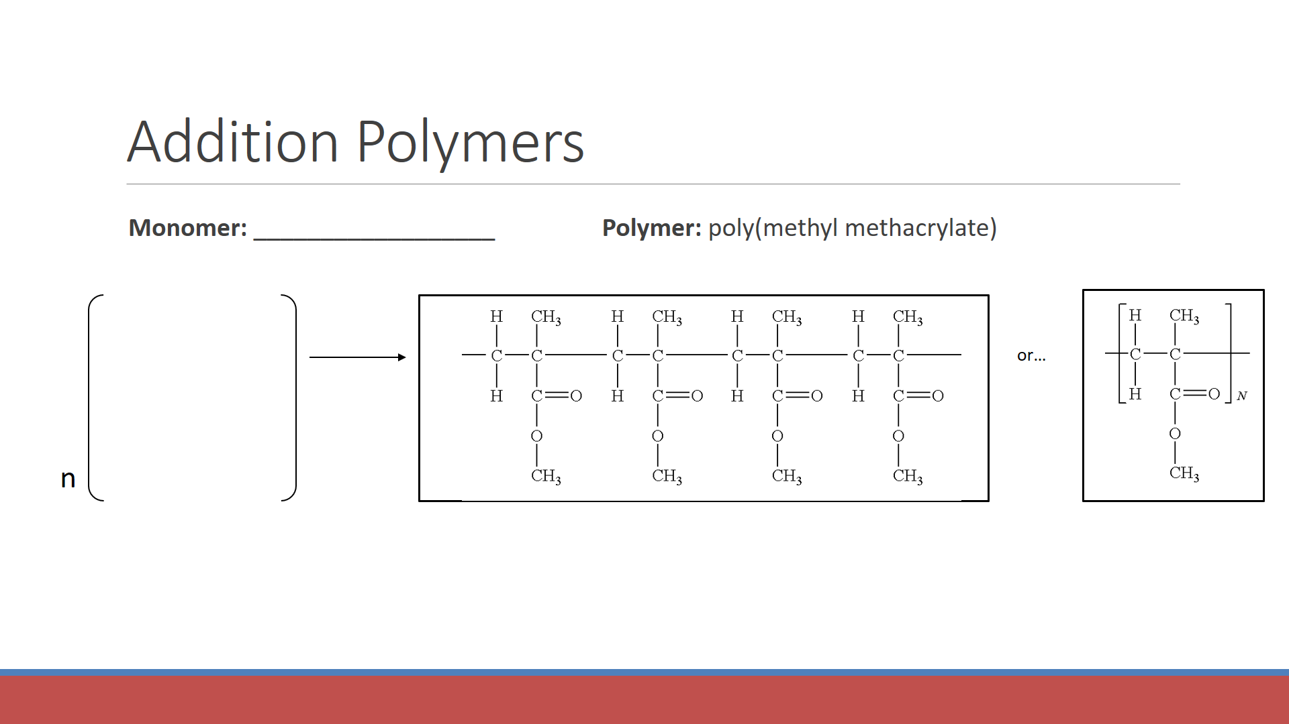

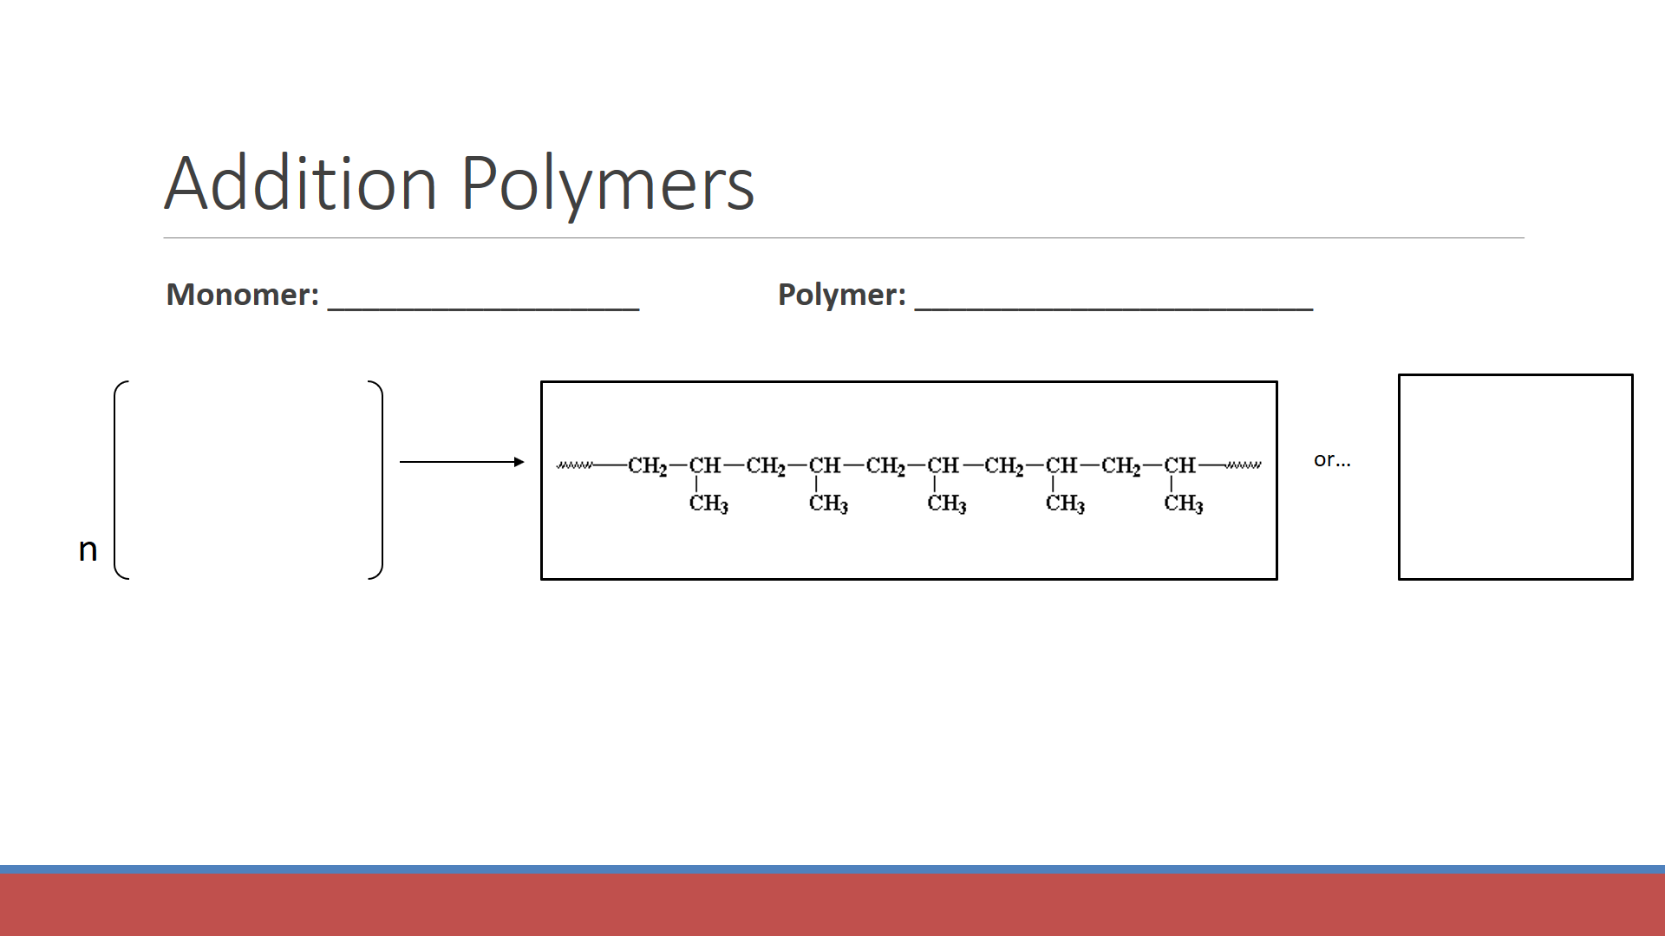

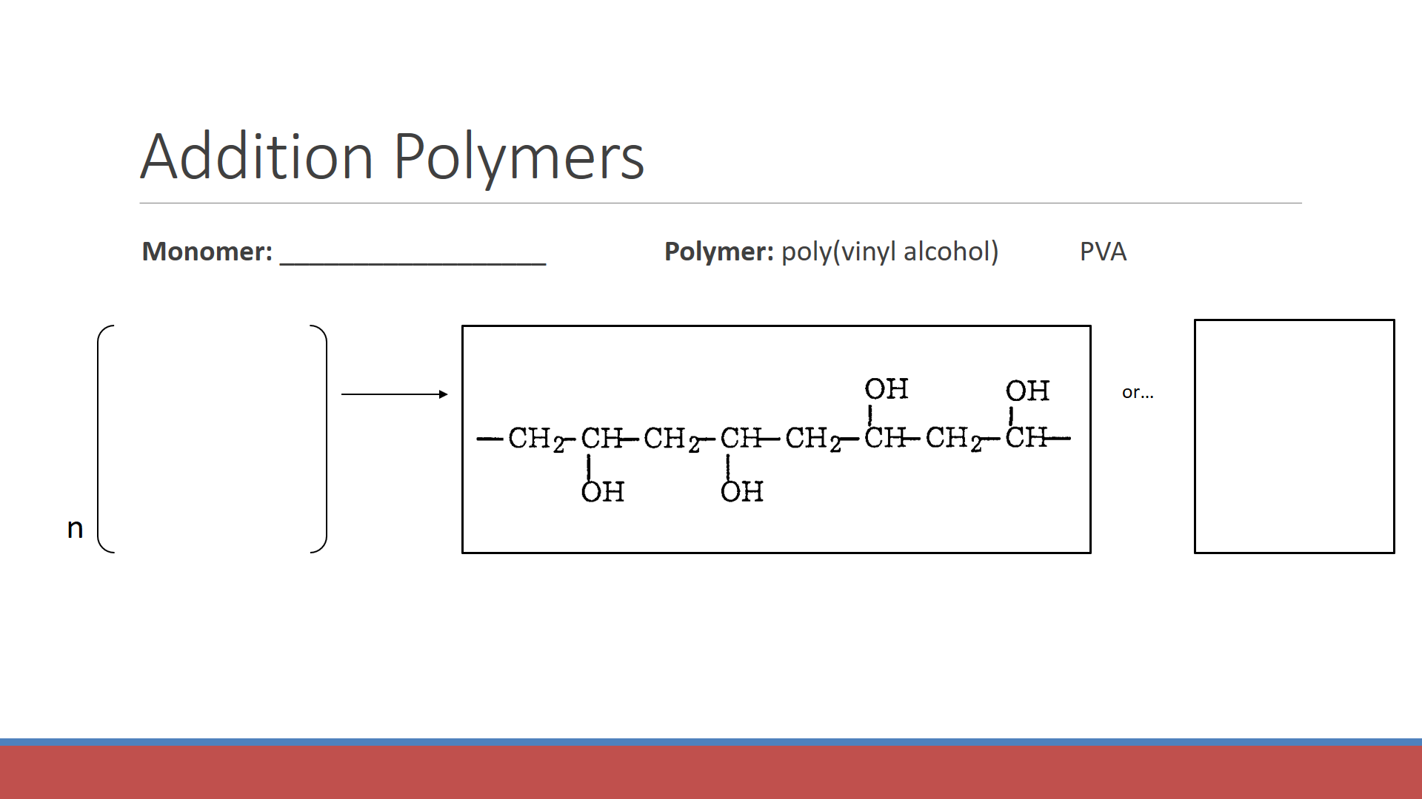

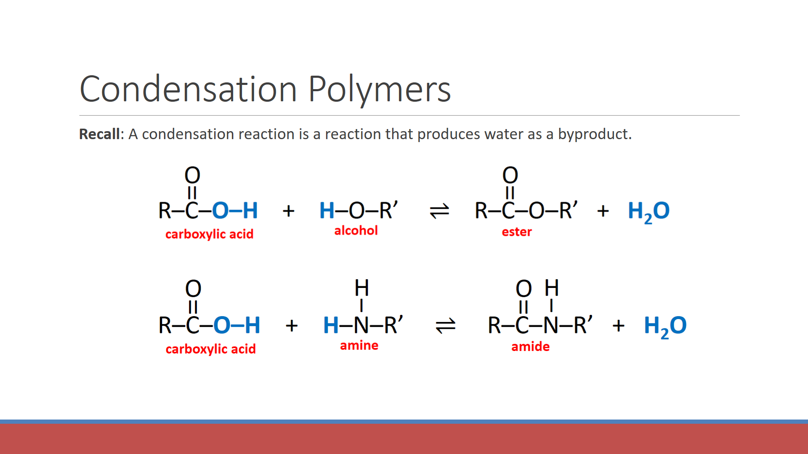

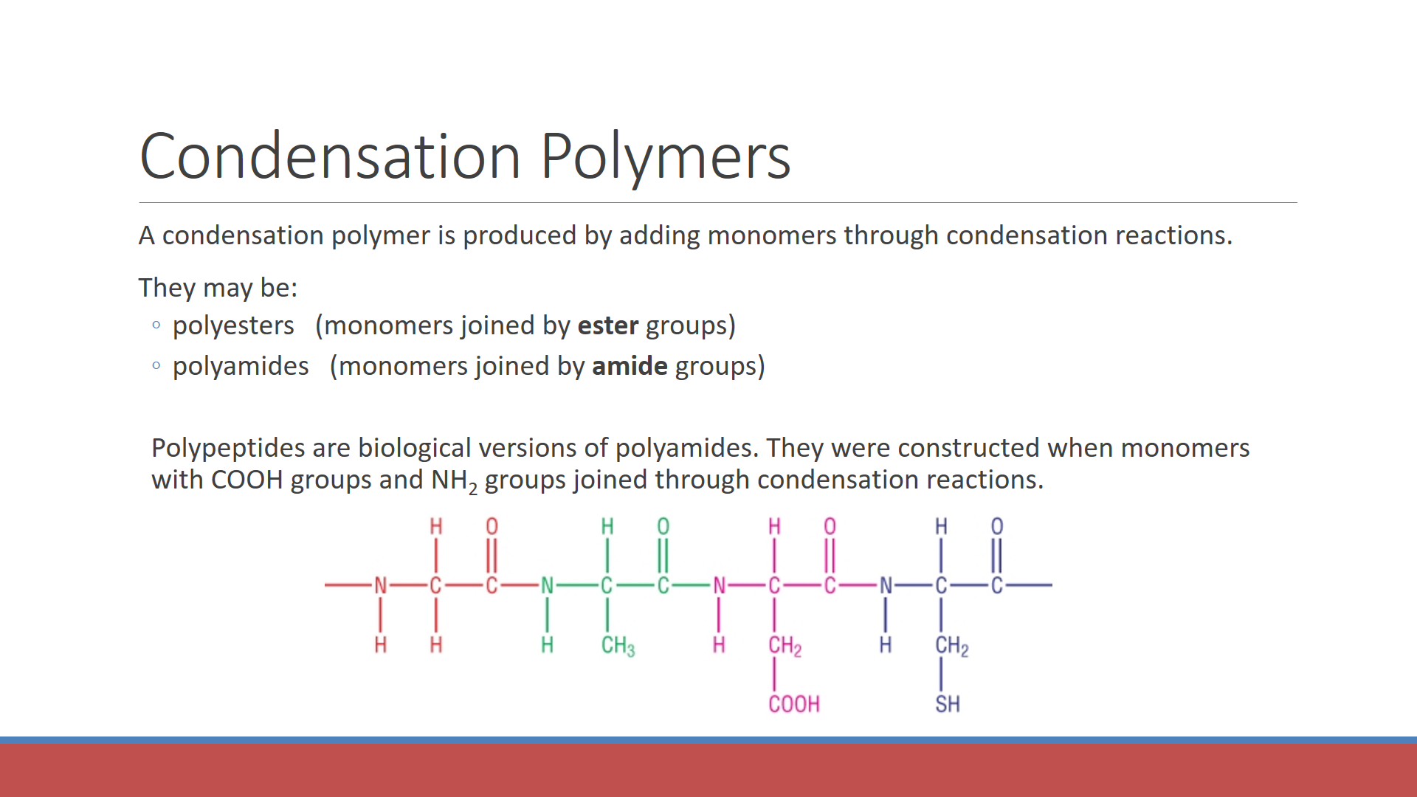

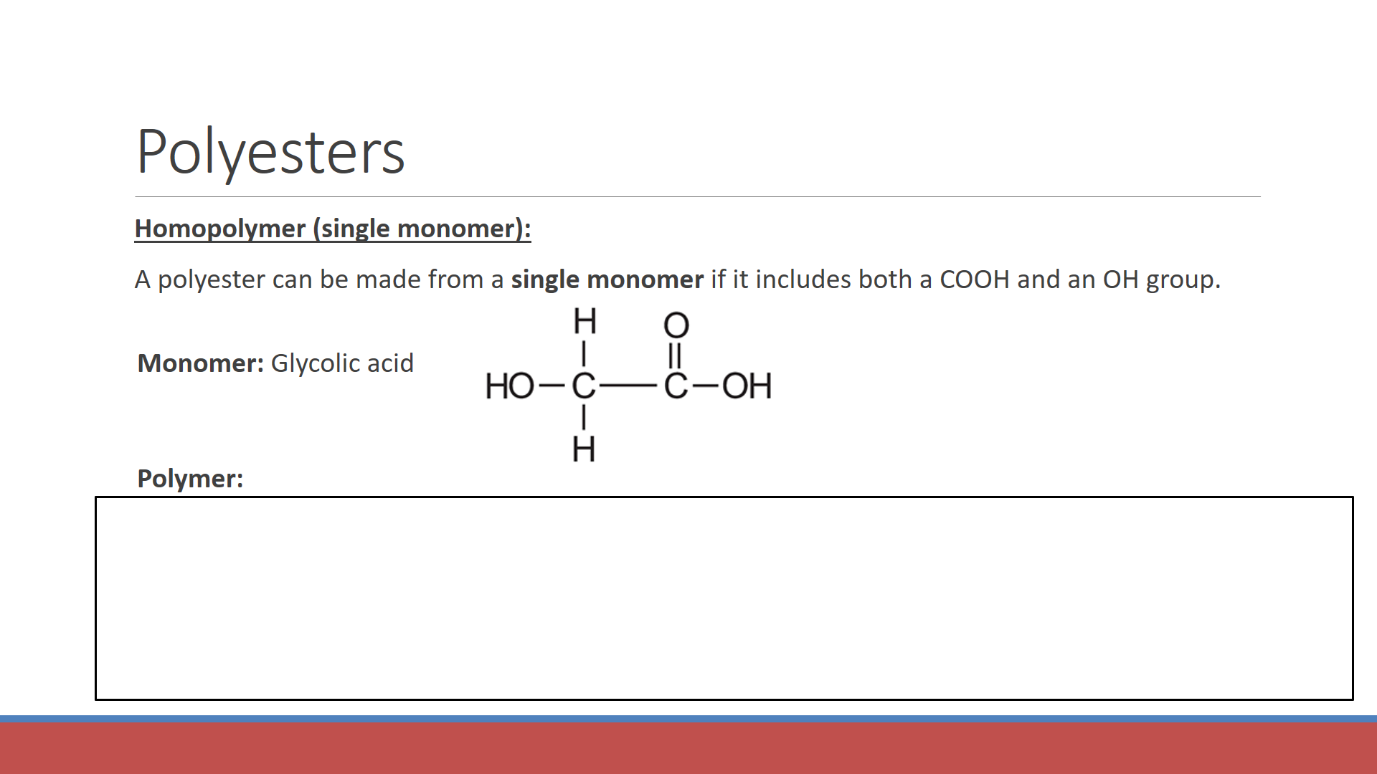

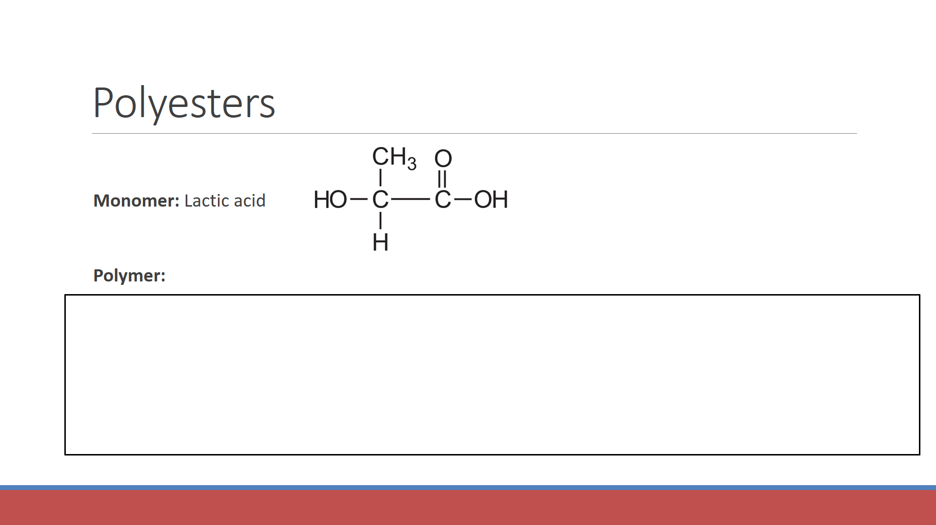

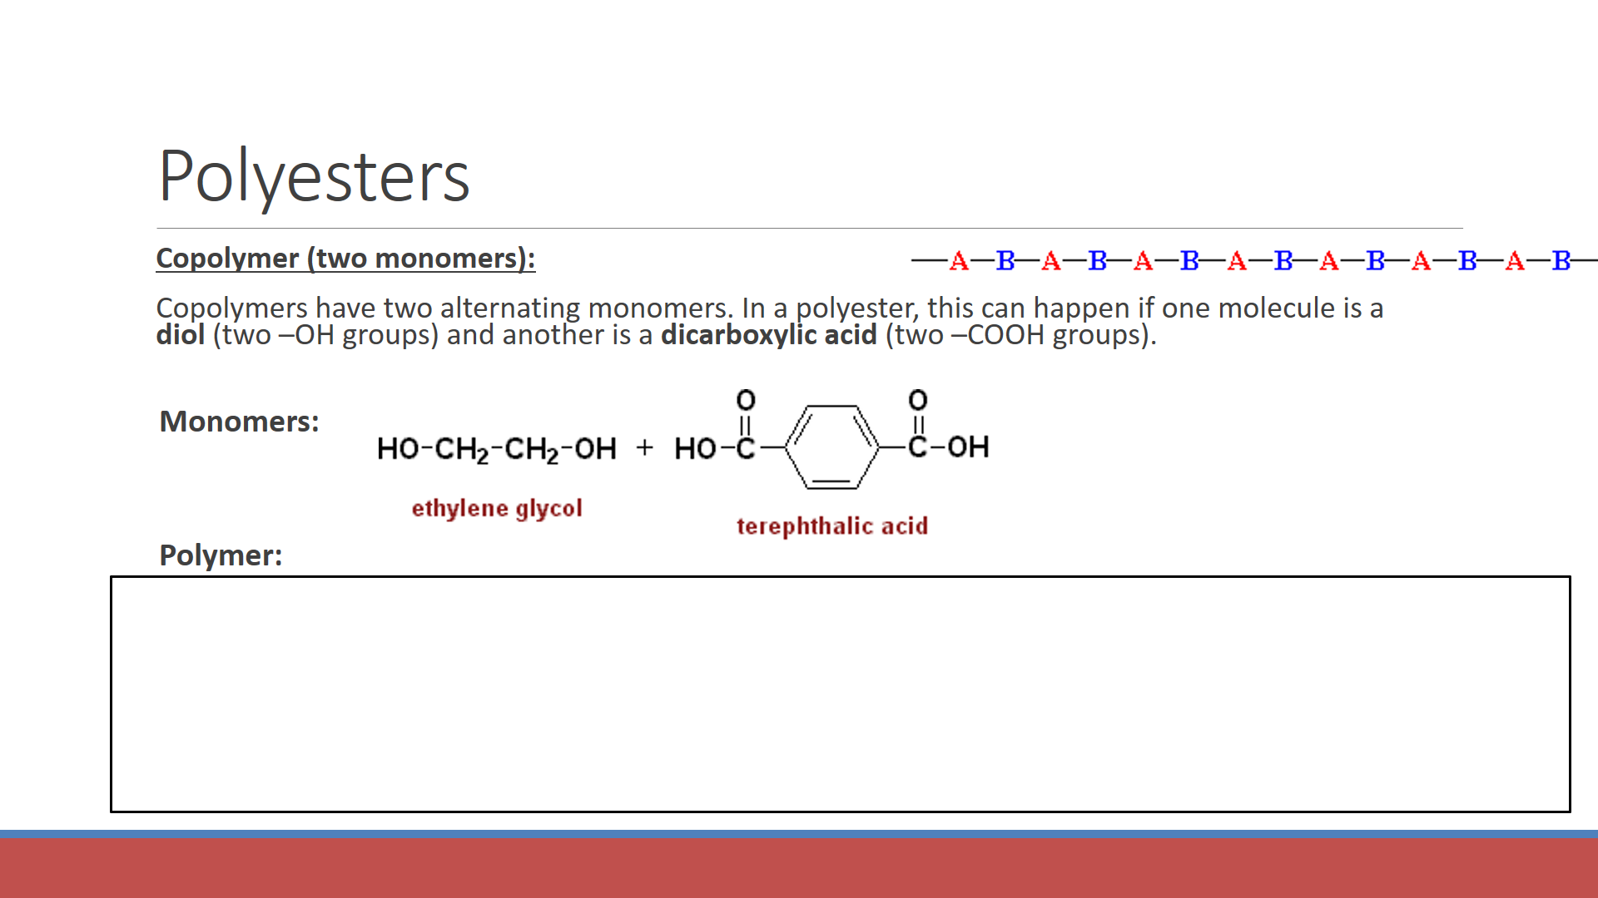

**Going backwards:**

1. Find the ester groups
2. Break the ester groups in two (split between the C-O)
3. Figure out what the monomers must have been.
   1. Turn the C=O back into COOH
   2. Turn the -O- back into -OH

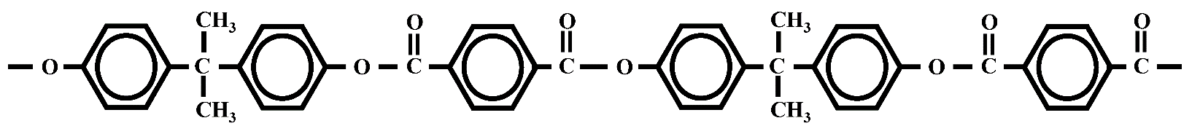

Draw the structure of the monomer(s) that were used to make this polyester. Is it a homopolymer or a copolymer?

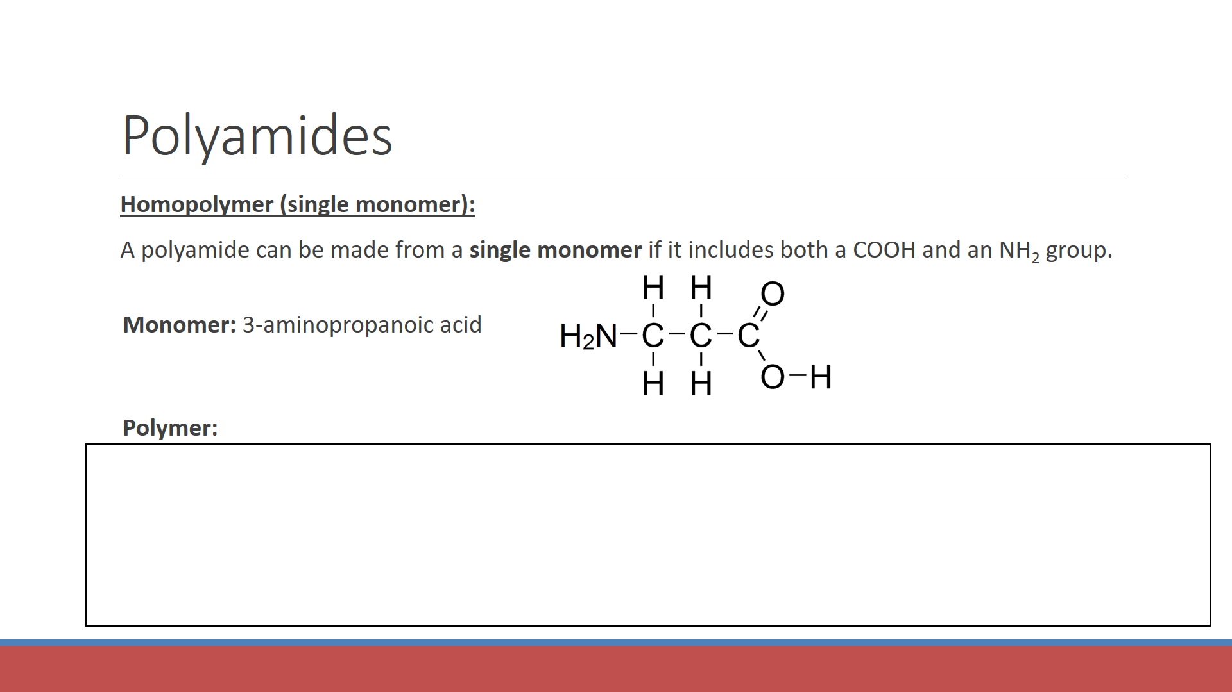

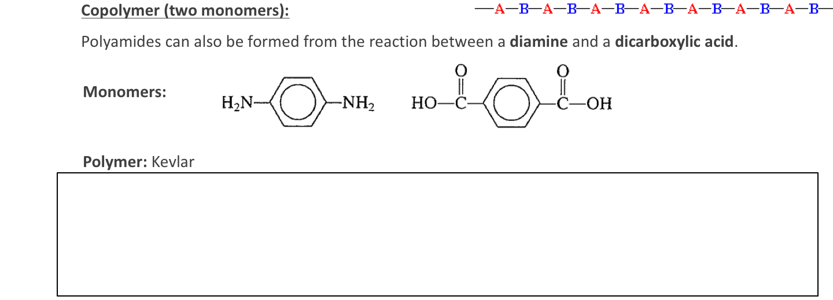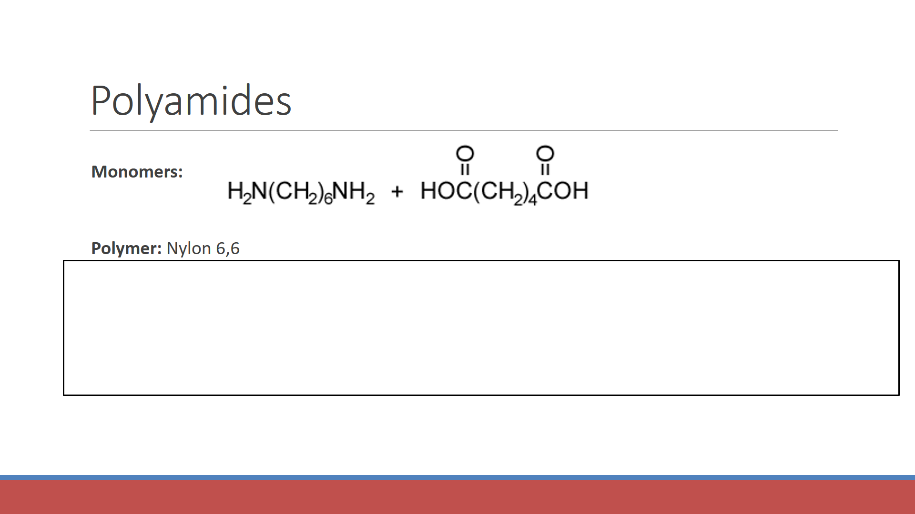

**Going backwards:**

1. Find the amide groups
2. Break the amide groups in two (split between the C-N)
3. Figure out what the monomers must have been.
   1. Turn the C=O back into COOH
   2. Turn the -NH- back into -NH2

**Polymer:** Nylon 6MDX

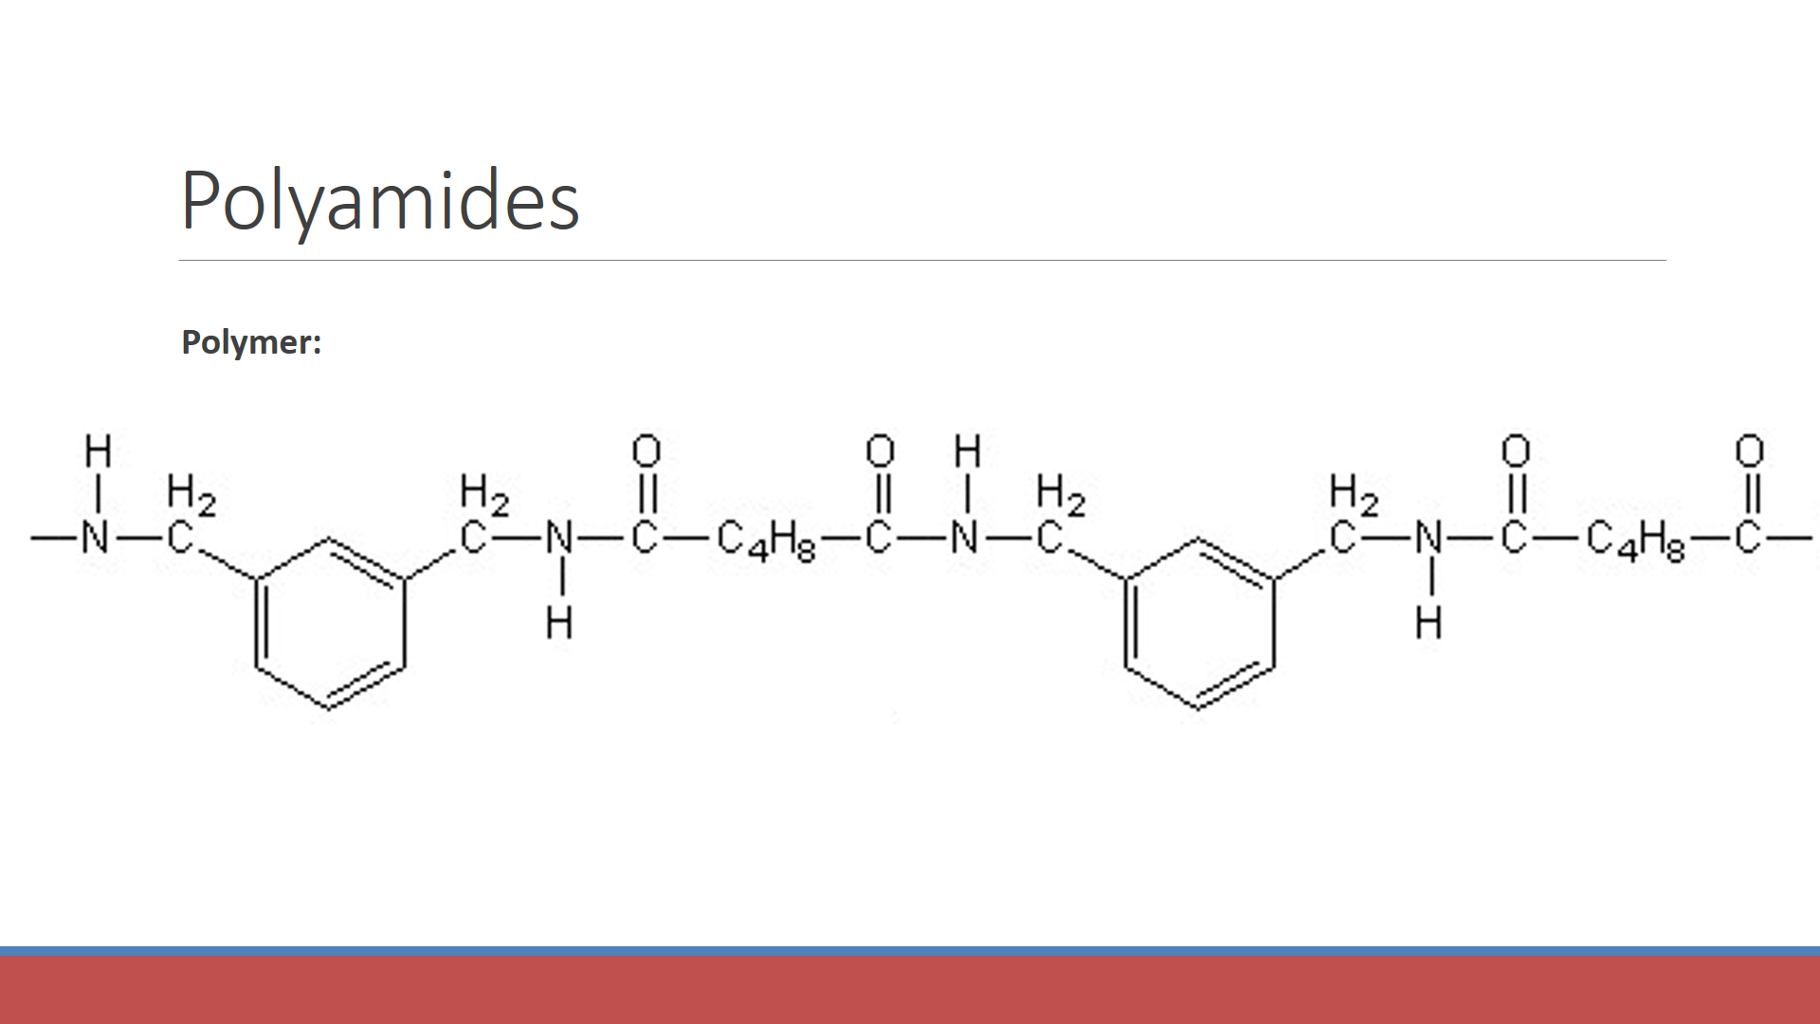

Draw the structure of the two monomers used to make this compound.

and

**REVIEW:** Draw the monomers used to make the following polymers.

|  |  |
| --- | --- |
| **Polymer** | **Monomer(s)** |
|  |  |
|  |  |
|  |  |
|  |  |

**Recommended polymer videos:**  <http://webplayer.clickview.com.au/ev.aspx?p=z_kW&ssi=0&a=true> *(Addition polymers)*

<http://webplayer.clickview.com.au/ev.aspx?p=3d_O&ssi=0&a=true> *(Condensation polymers)*

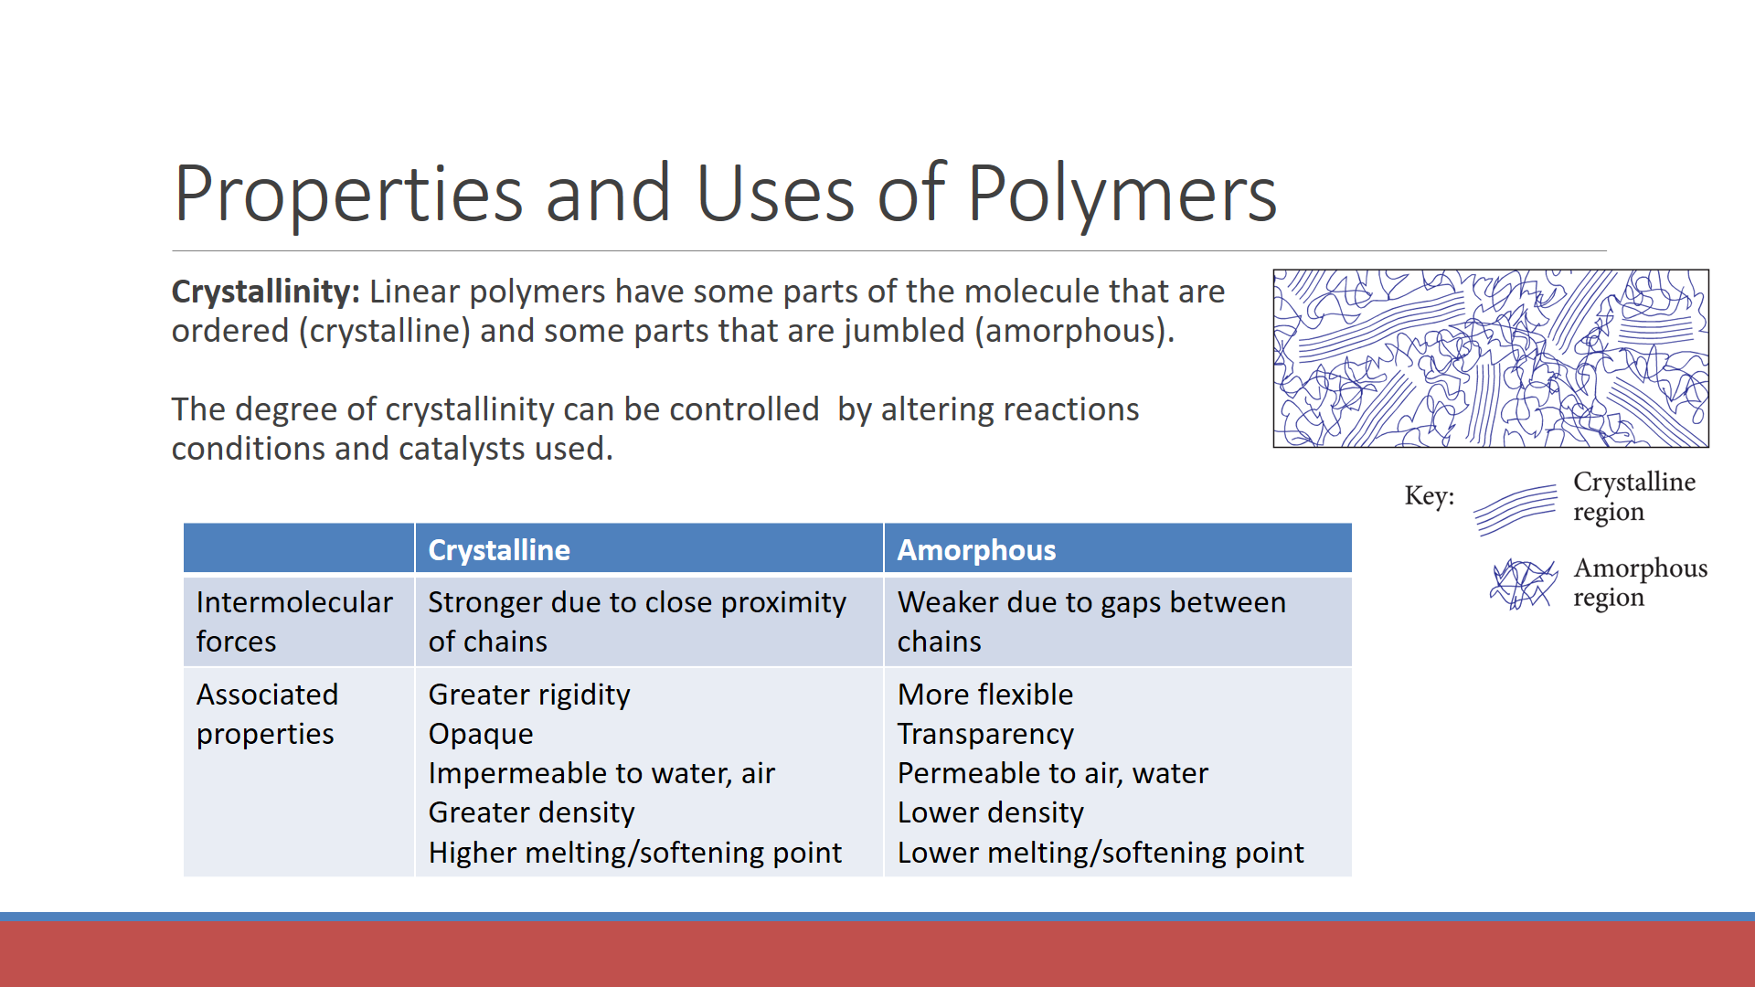

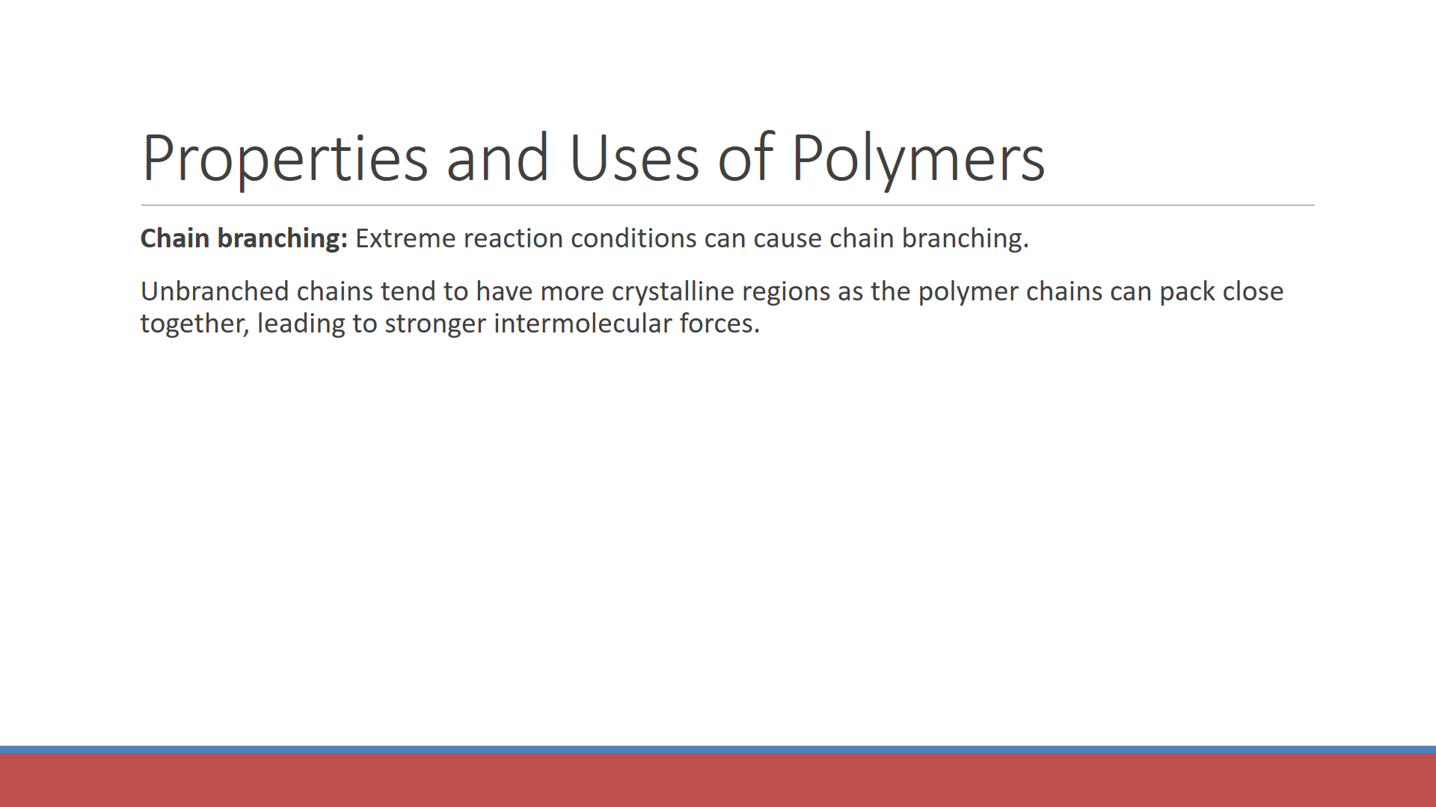

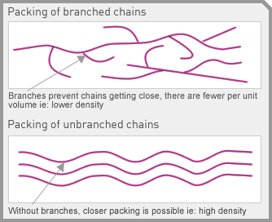

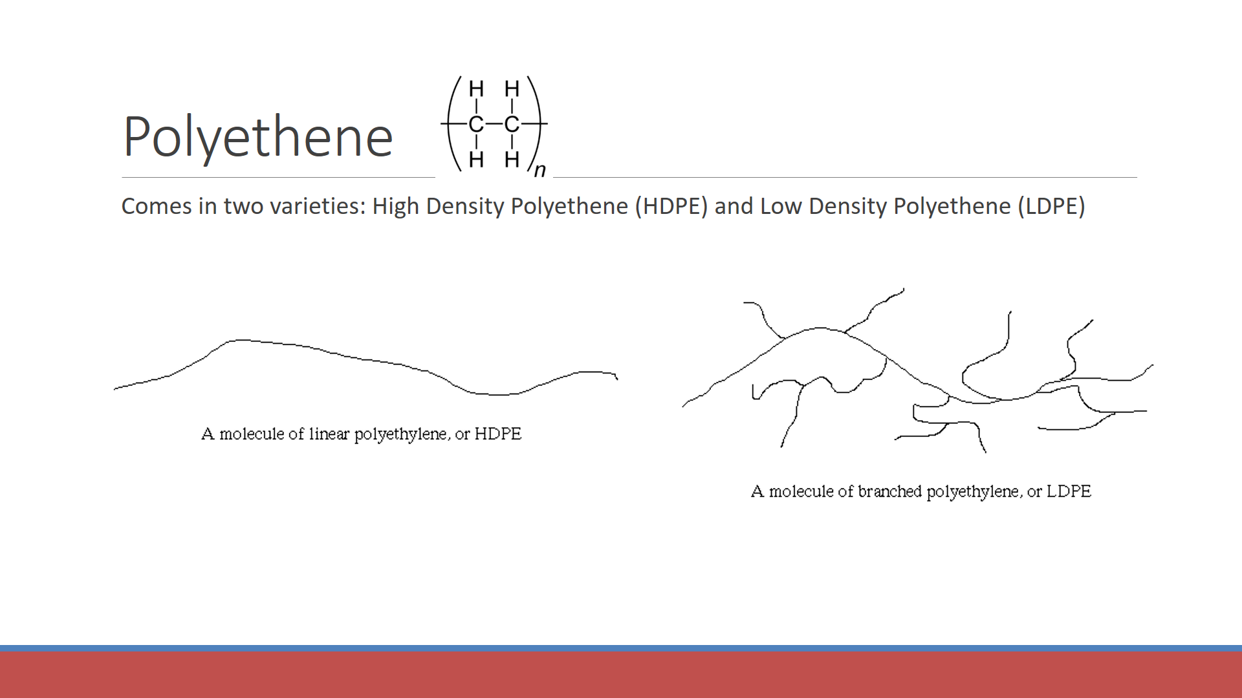

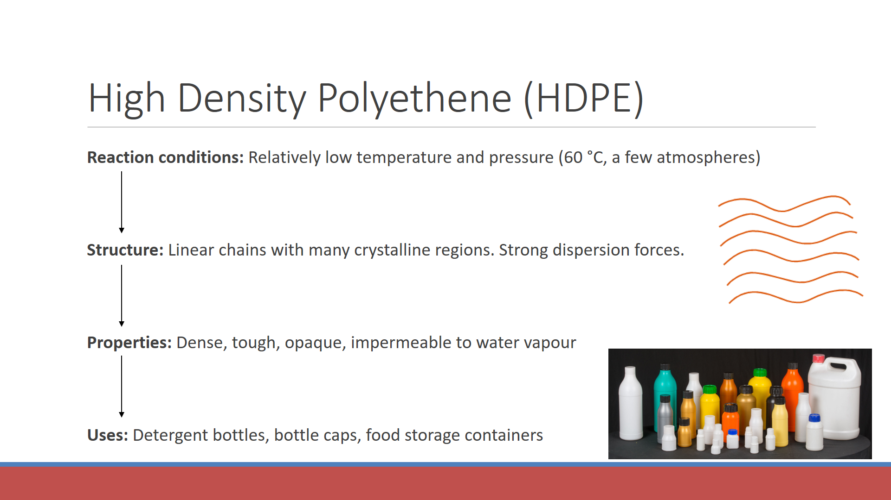

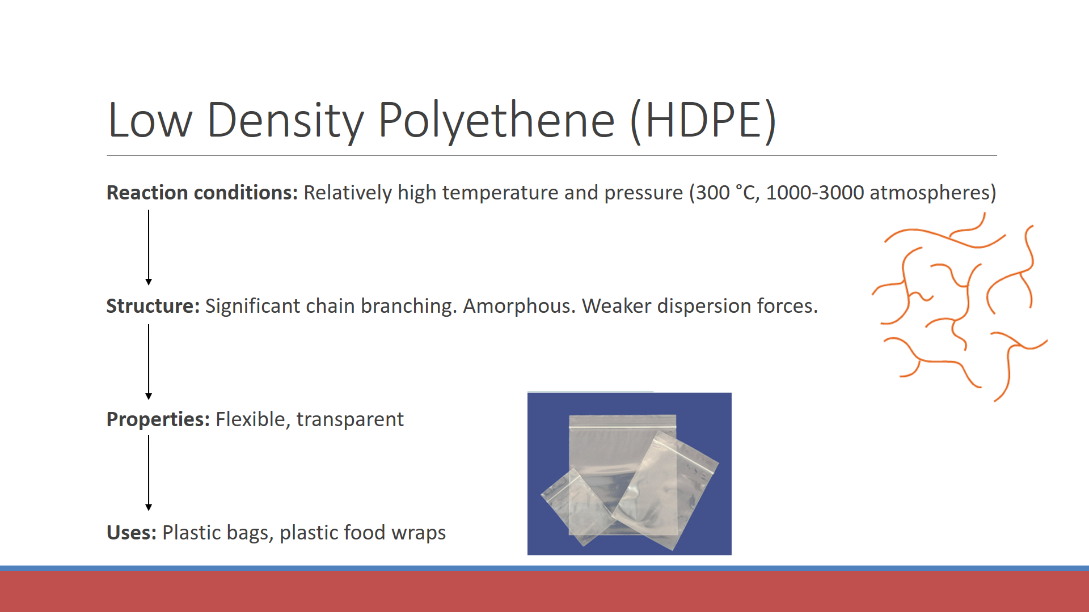

**Syllabus:** “industry produces a **vast range of plastics**, including addition polymers (polyethene, polytetrafluoroethene) and condensation polymers (nylon and polyethylene terephthalate [PET]) **which have different properties and uses**”

|  |  |  |  |
| --- | --- | --- | --- |
| **Polymer** | **Structure (repeating unit)** | **Properties** | **Uses** |
| Polytetrafluoroethene |  |  |  |
| Nylon |  |  |  |
| PET |  |  |  |

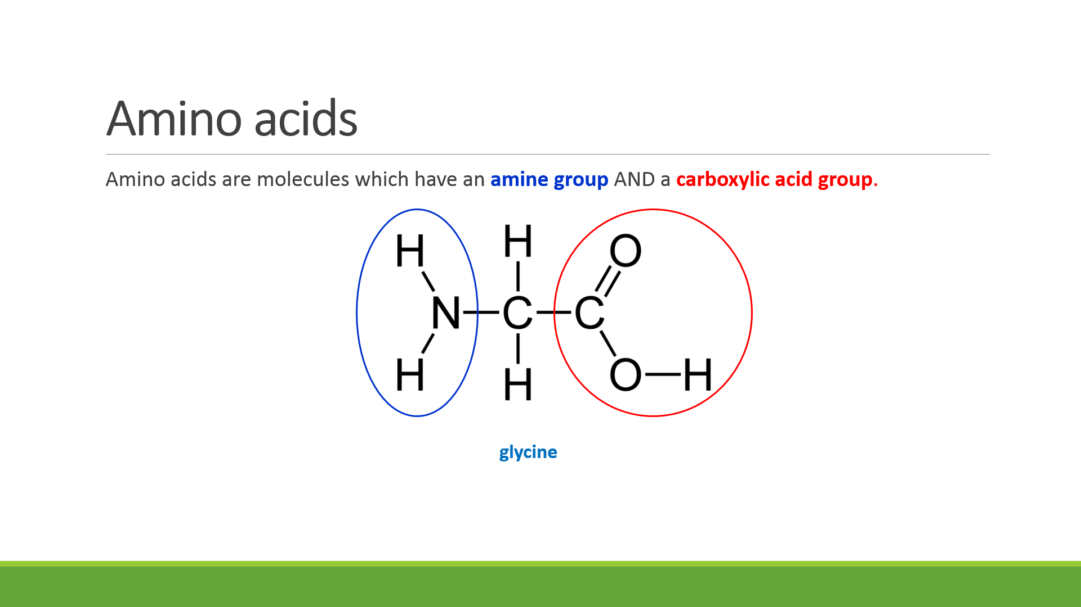 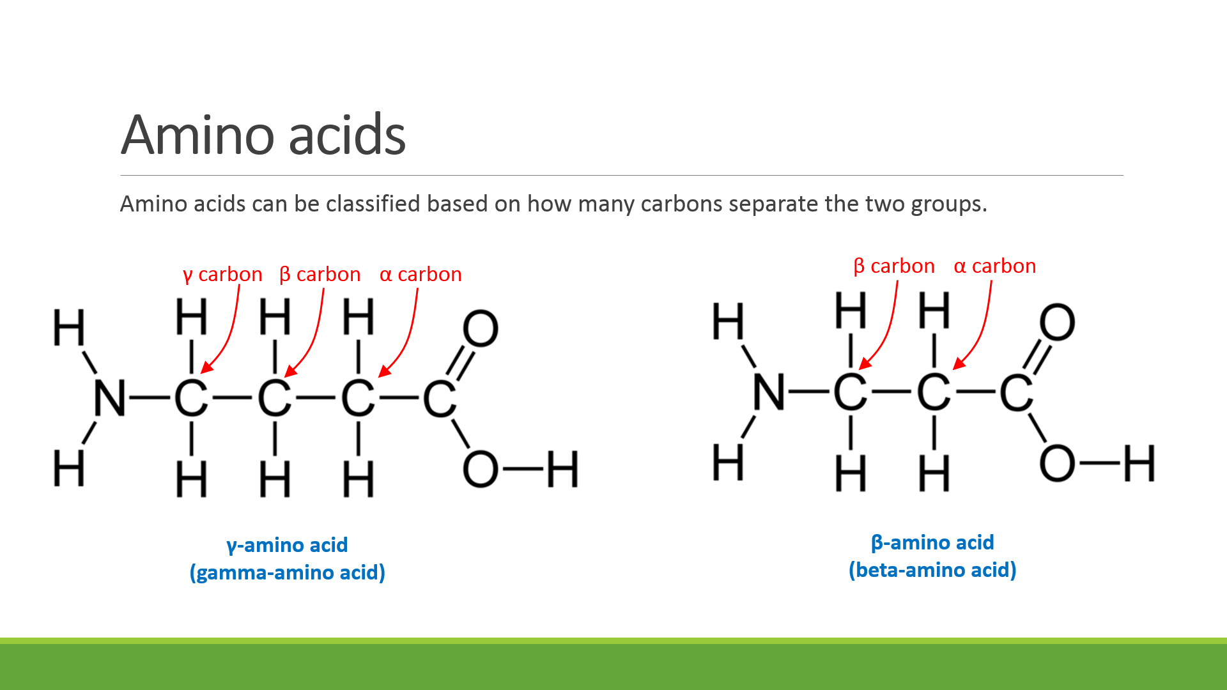

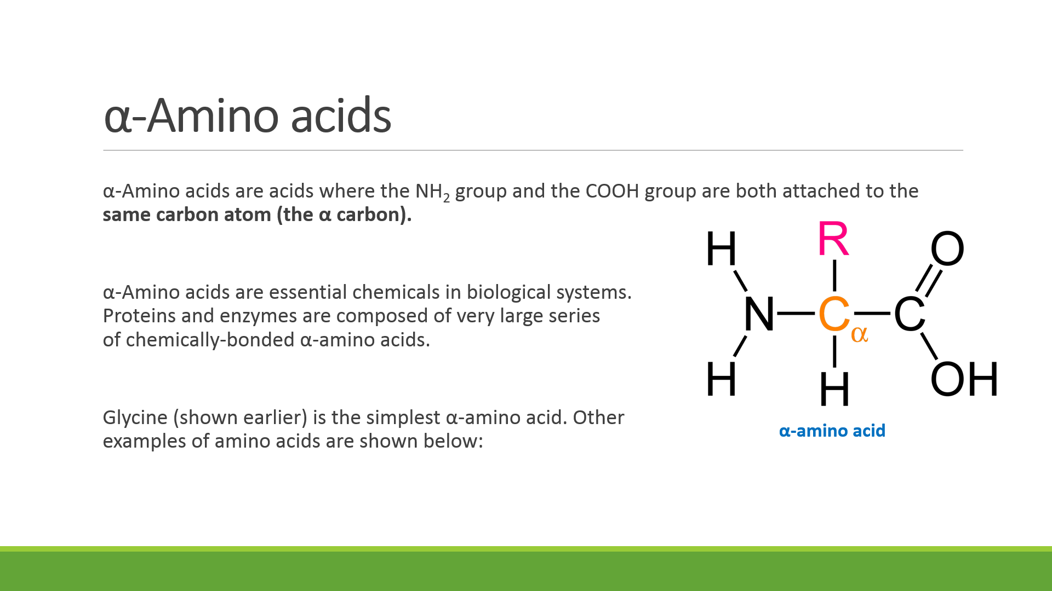

|  |  |  |  |
| --- | --- | --- | --- |
| https://upload.wikimedia.org/wikipedia/commons/6/62/Alanine.png | https://upload.wikimedia.org/wikipedia/commons/9/9b/Valine.png | http://photos1.blogger.com/blogger/2040/1480/400/aaLeucine.jpg |  |
| *Alanine* | *Valine* | *Leucine* | *Phenylalanine* |

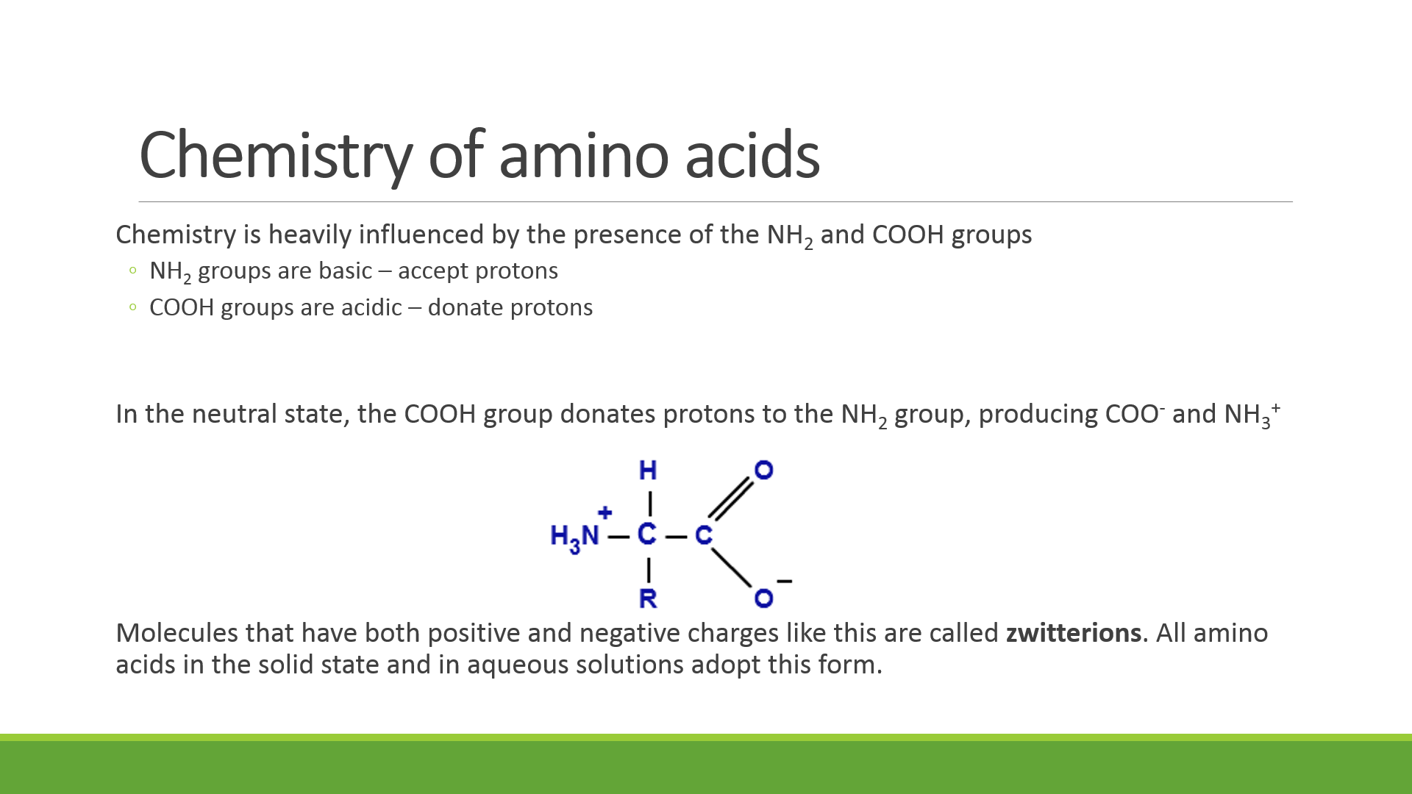

**Properties:**

Identify the predominant force of bonding within solid amino acids.

Predict the relative melting points of amino acids compared to similarly-sized alkanes, esters, carboxylic acids and alcohols. Justify your reasoning.

Explain how the solubility of amino acids in polar and non-polar solvents is related to their functional groups.

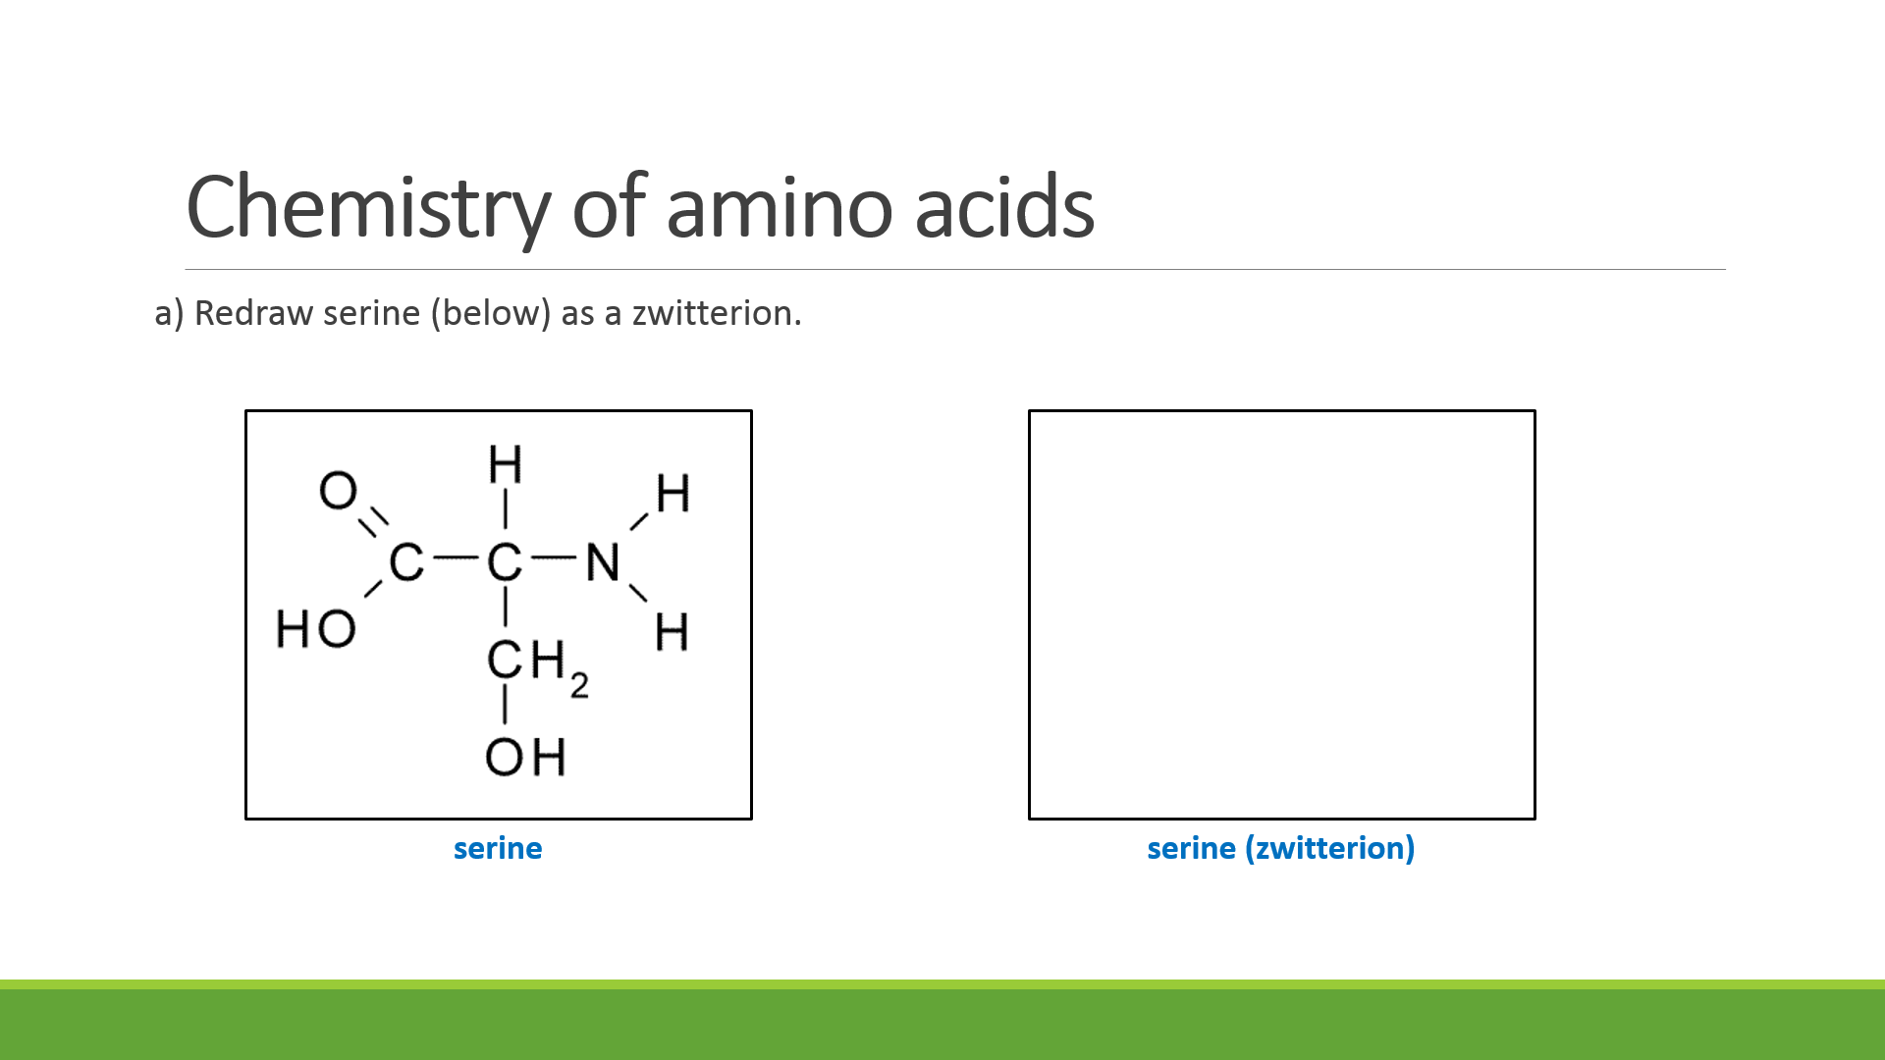

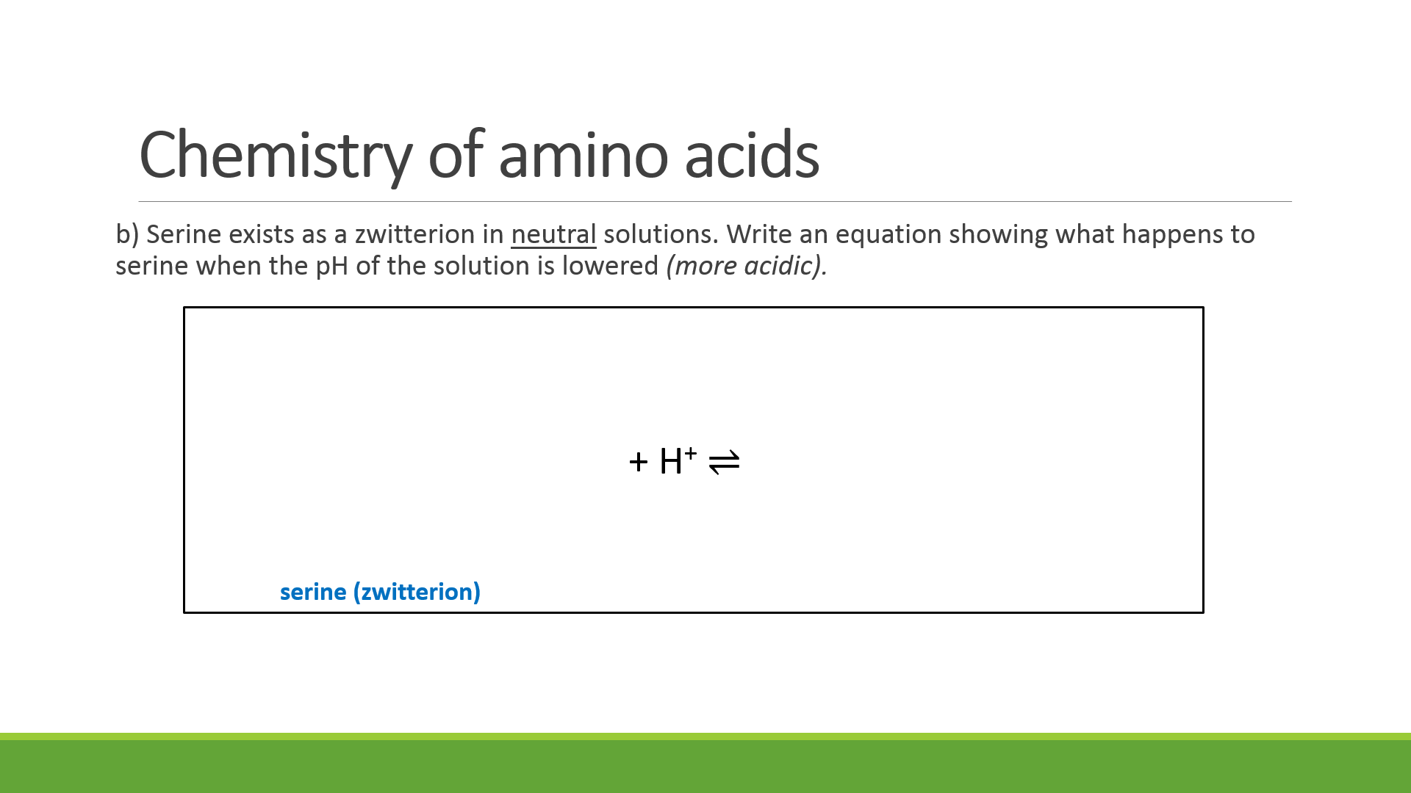

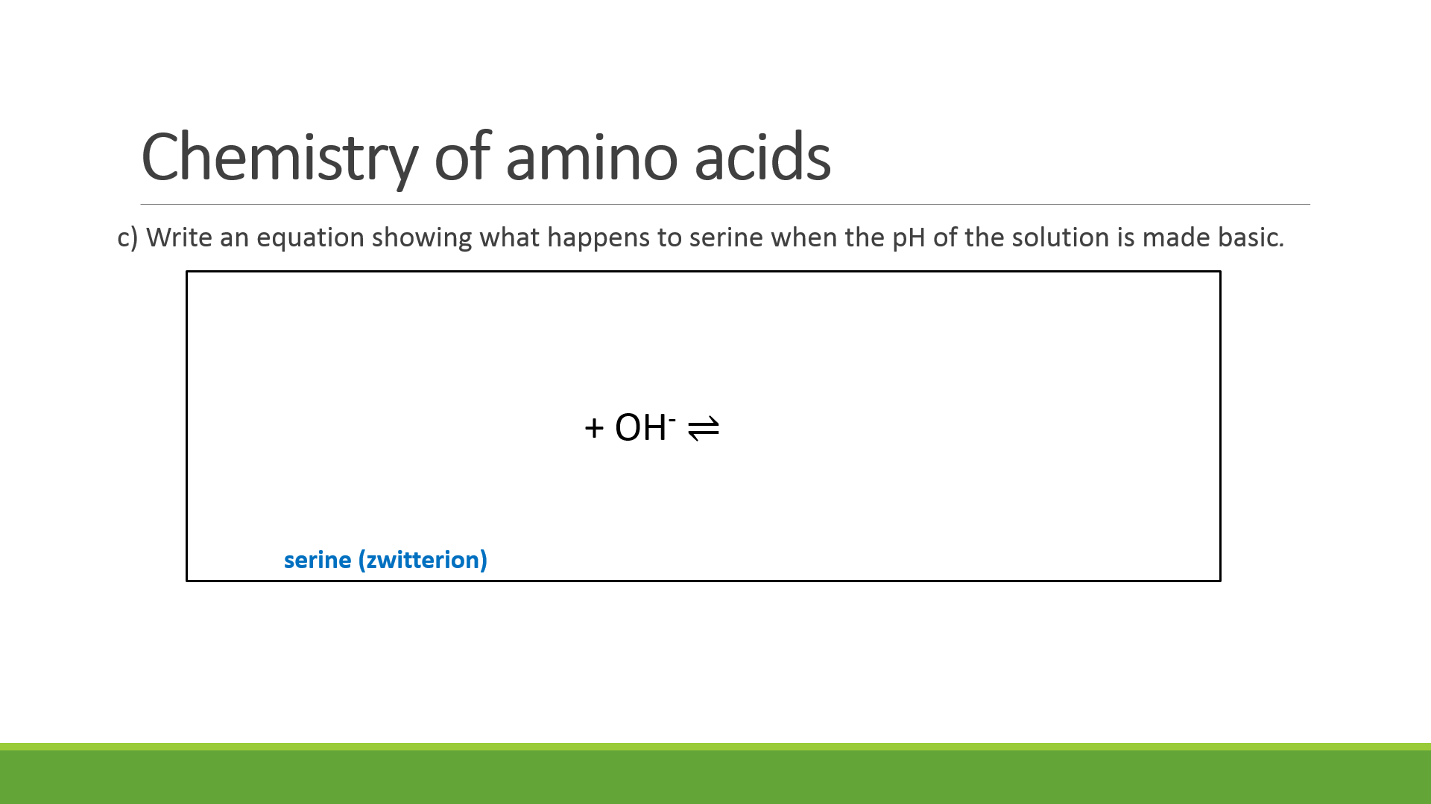

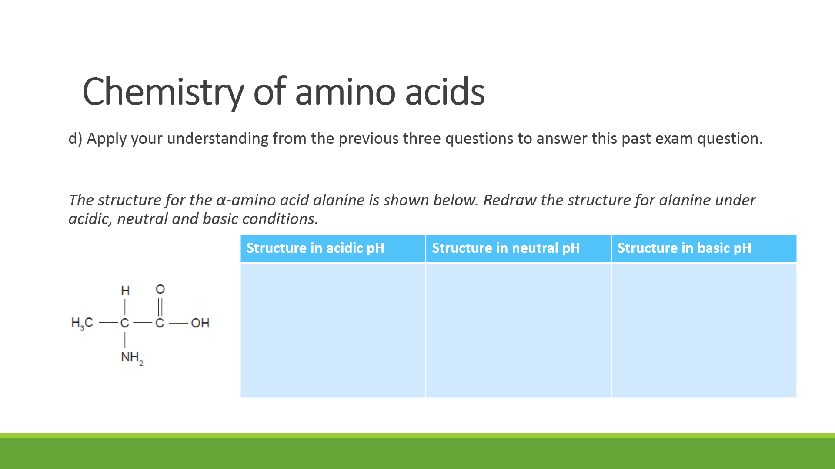

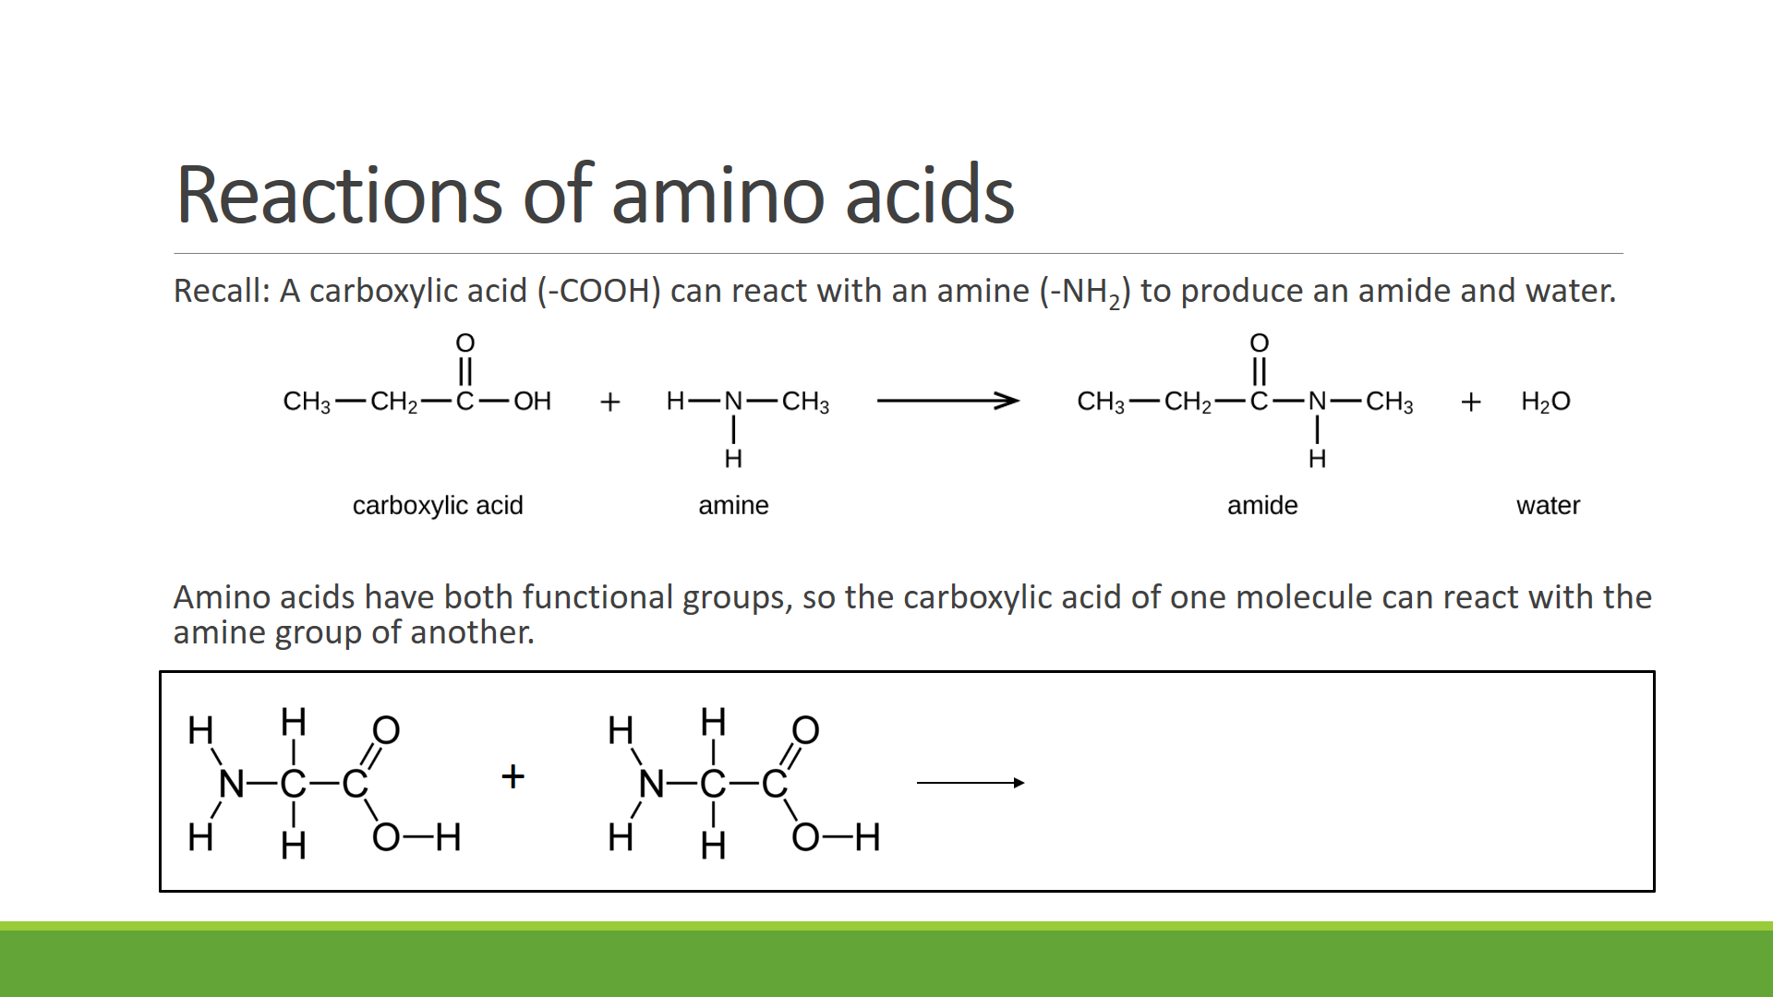

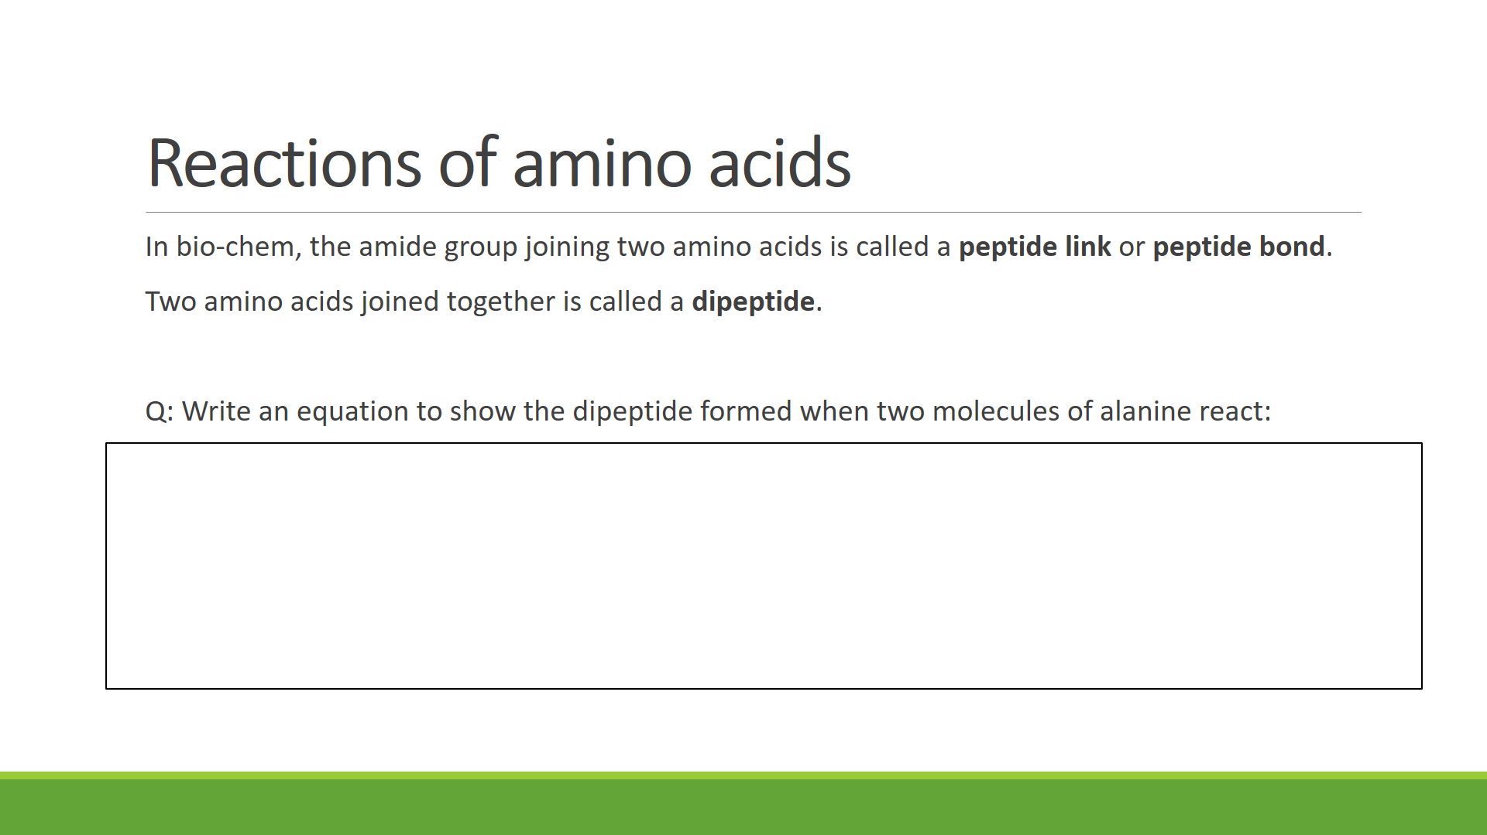

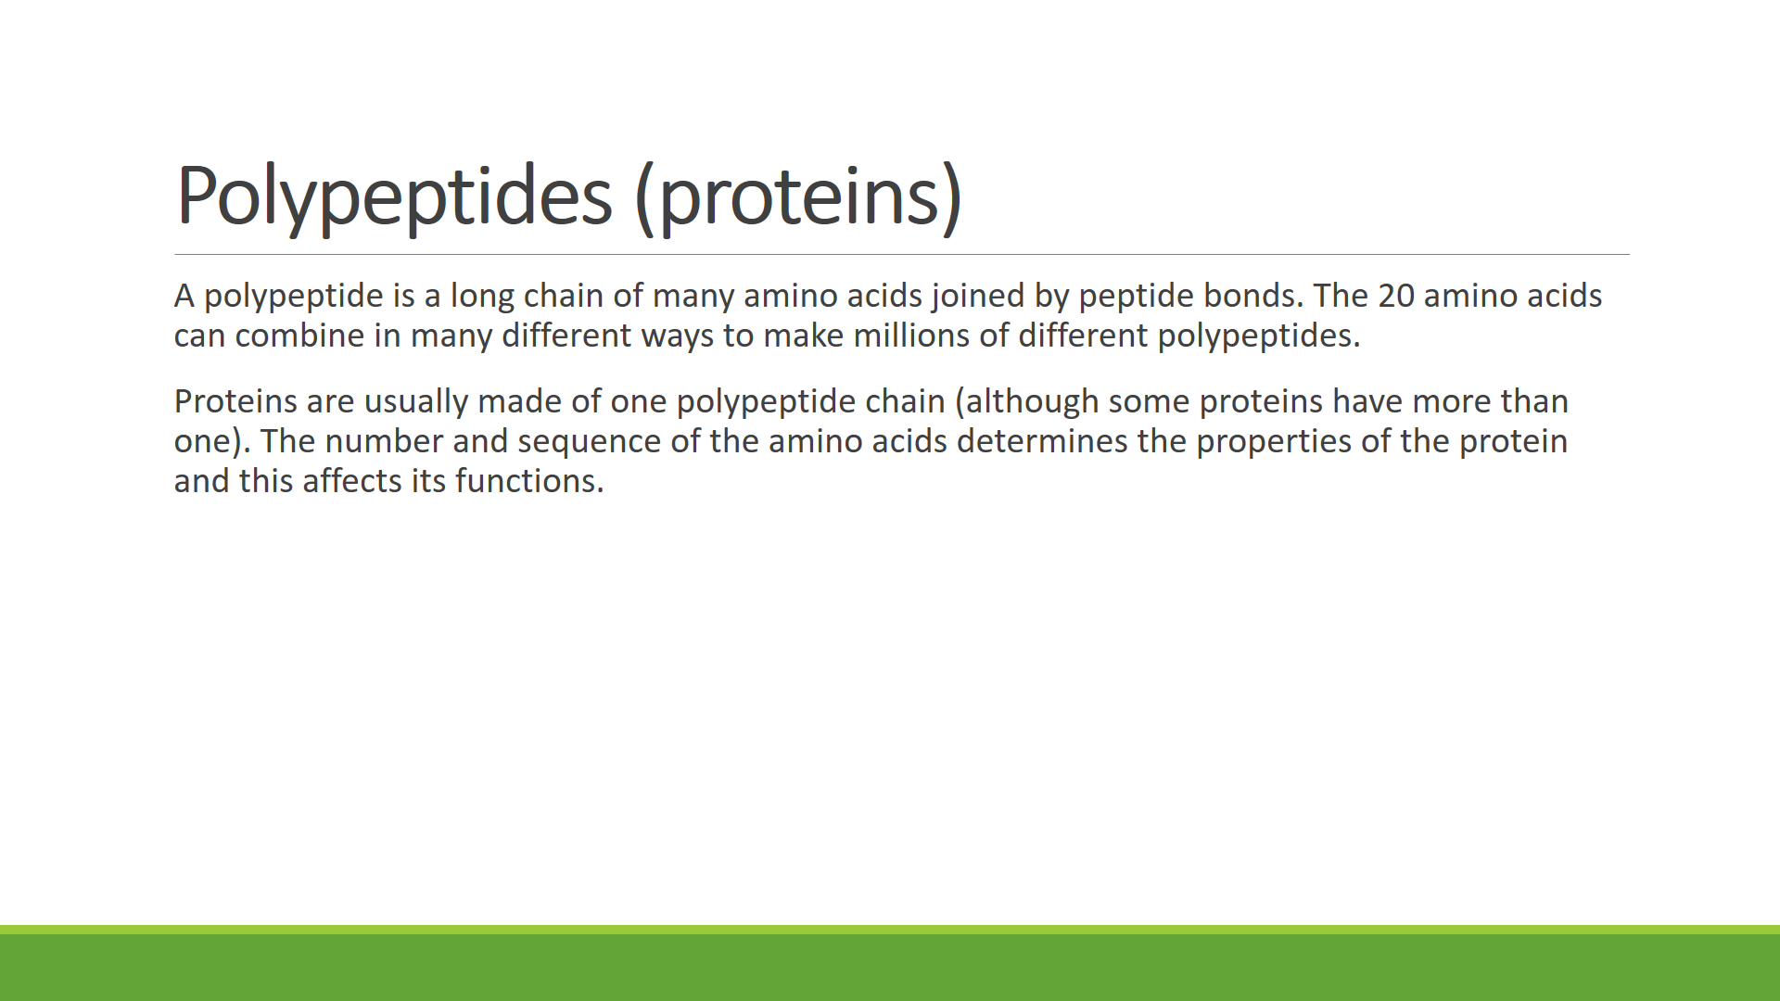

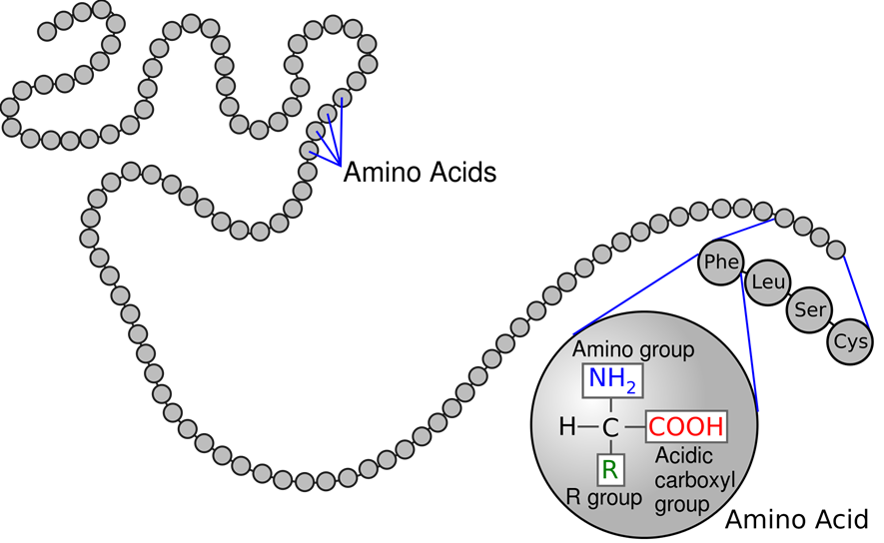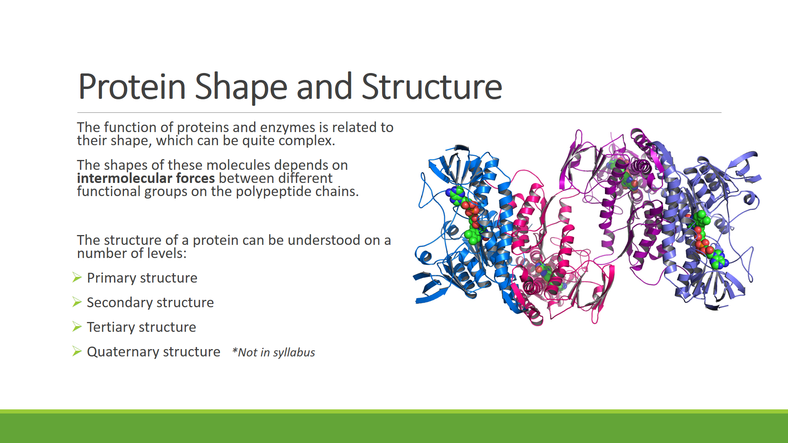

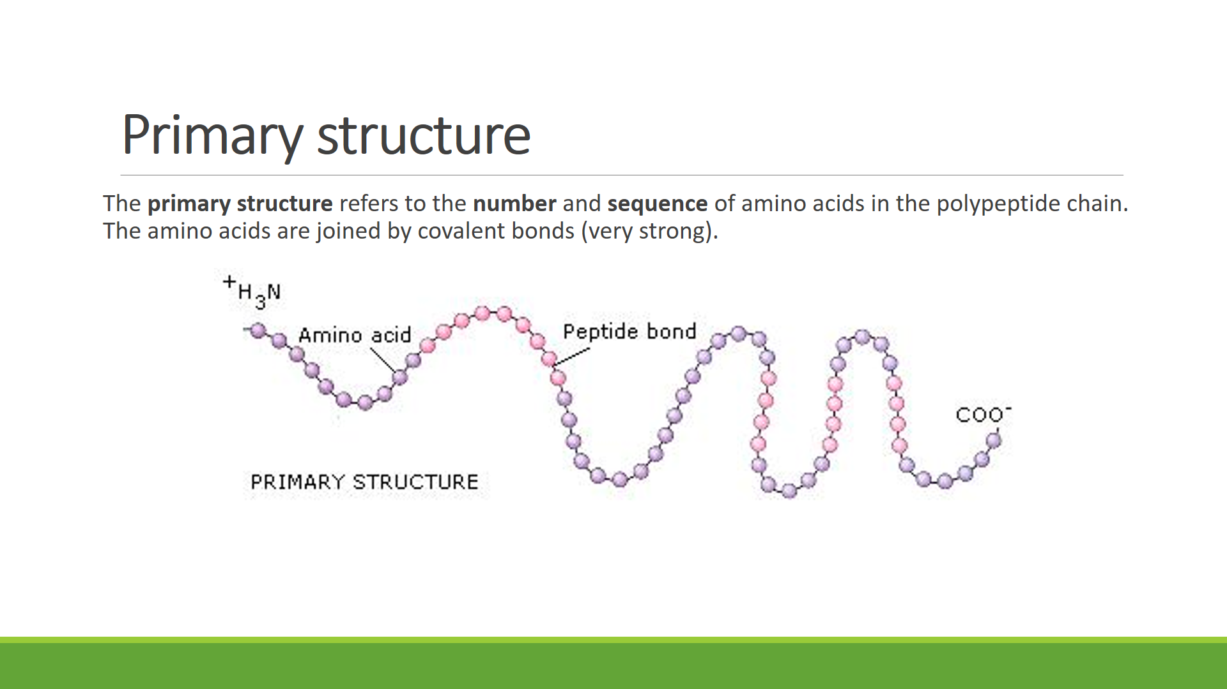

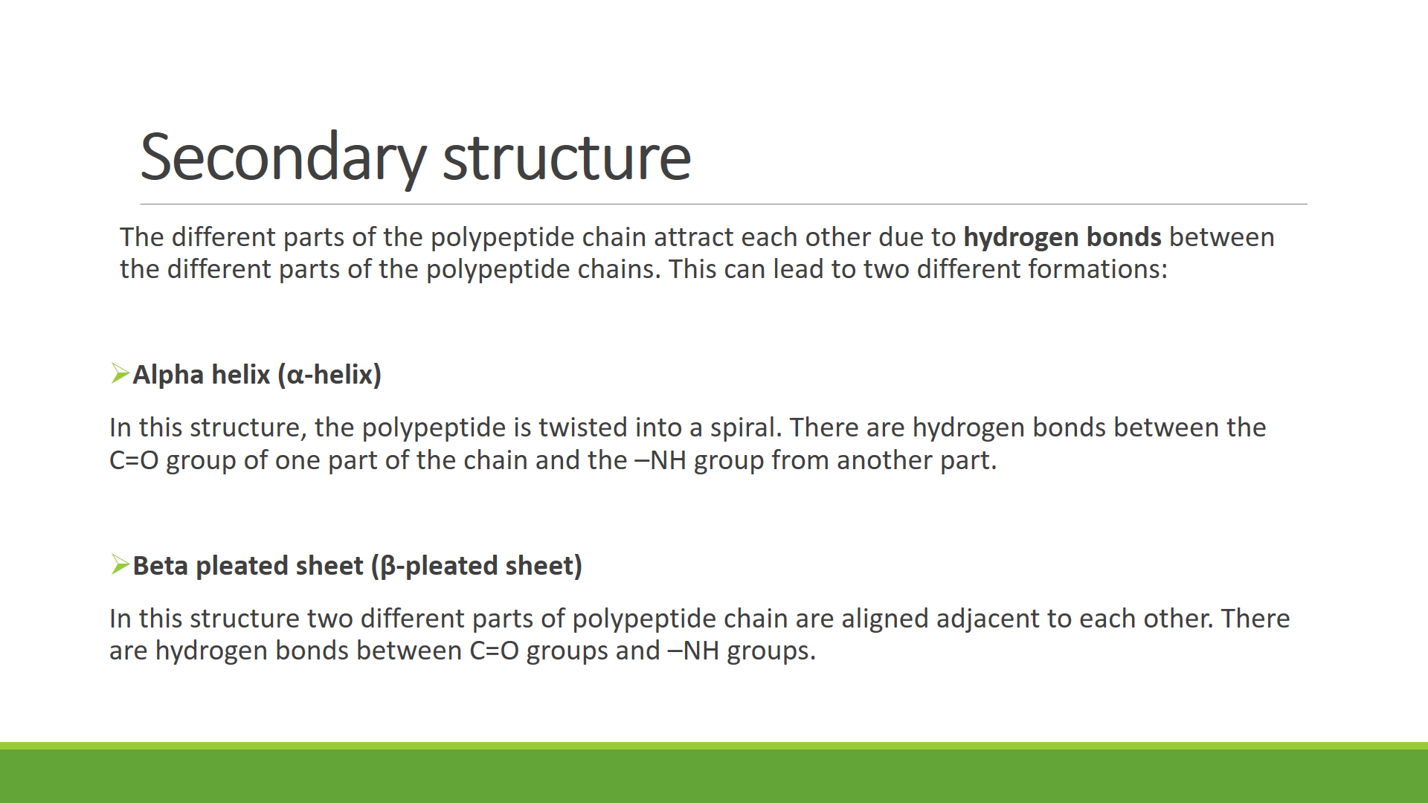

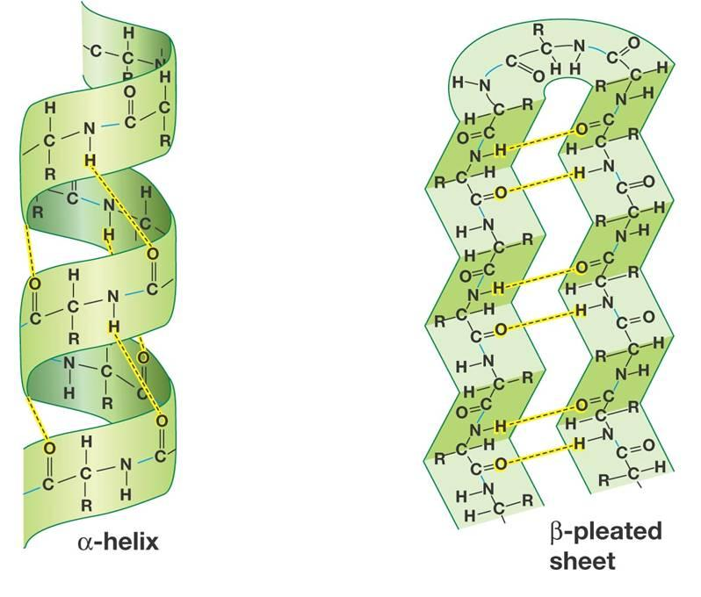

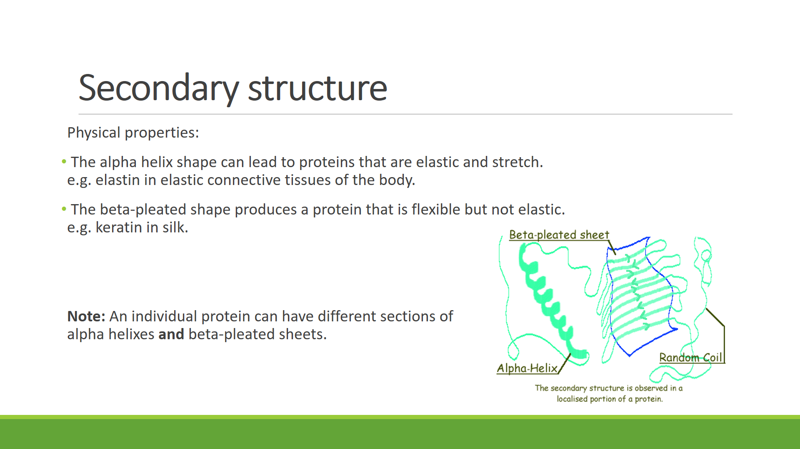

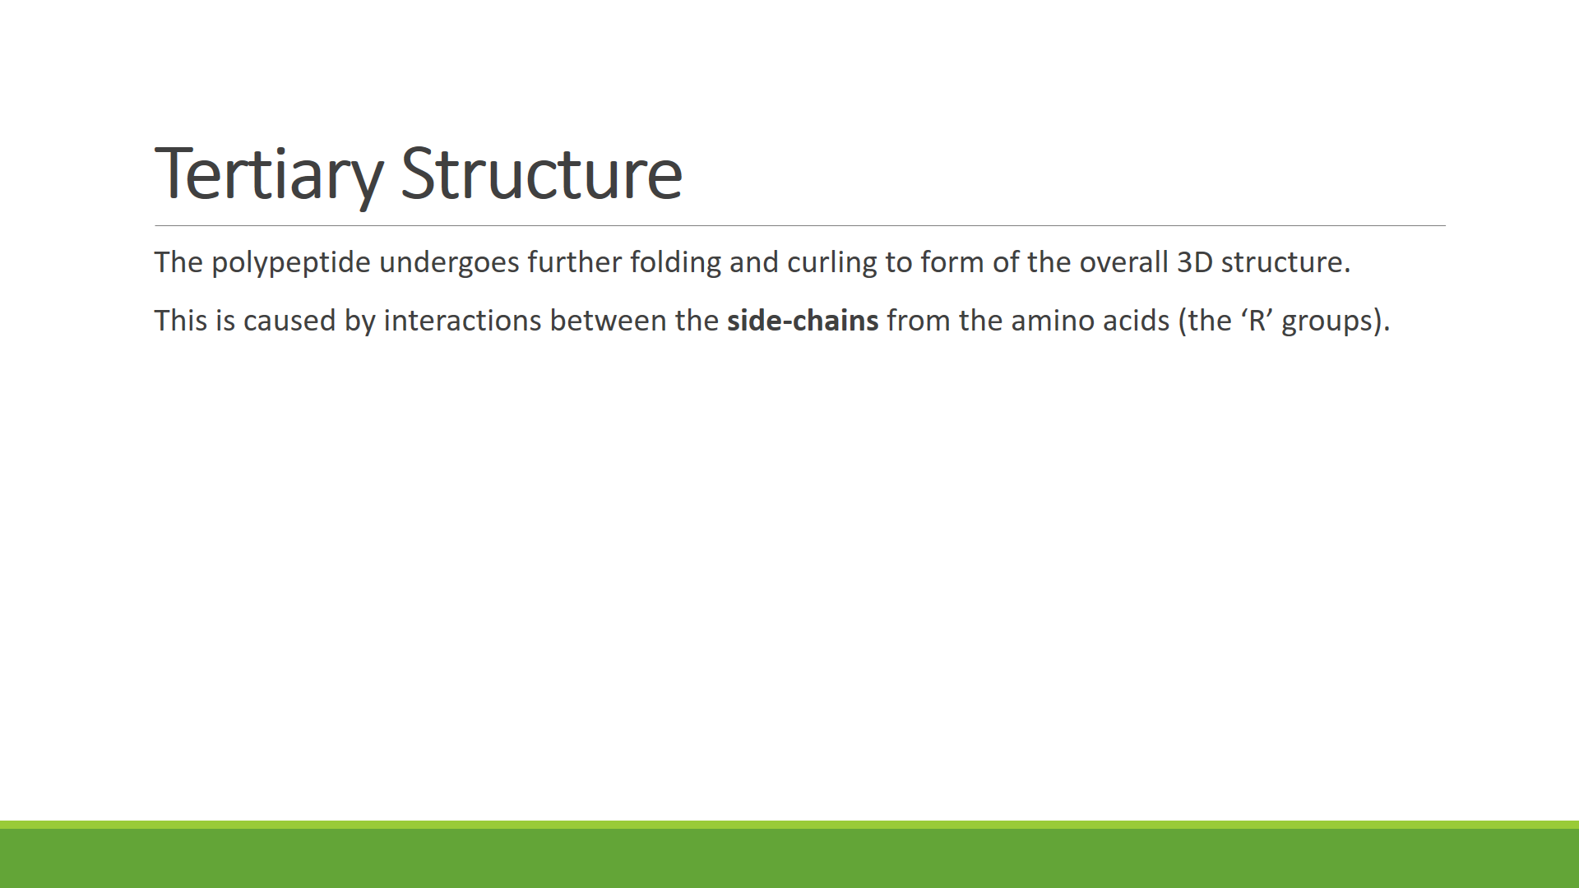

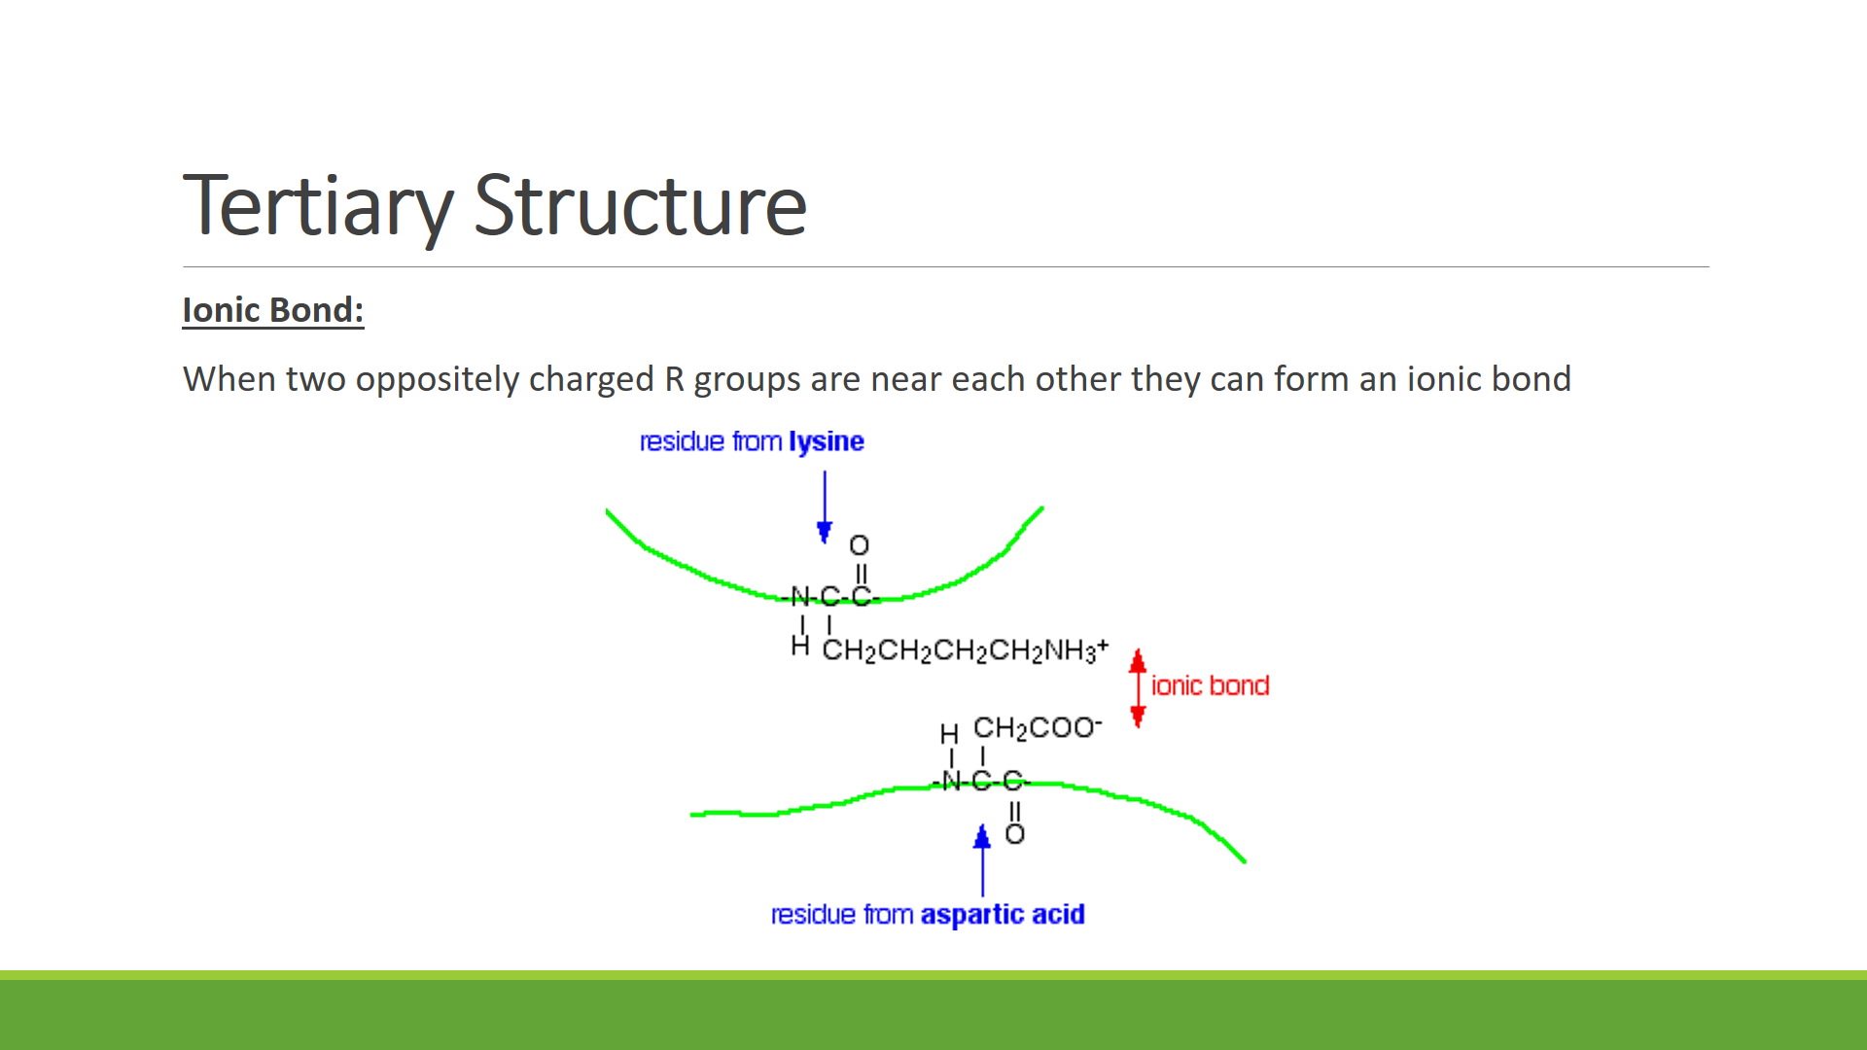

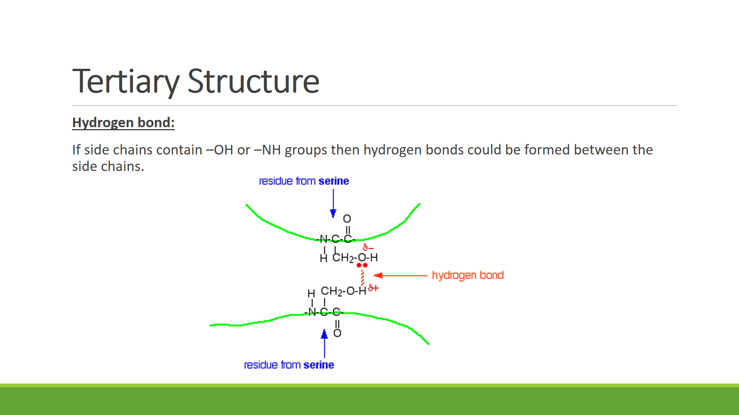

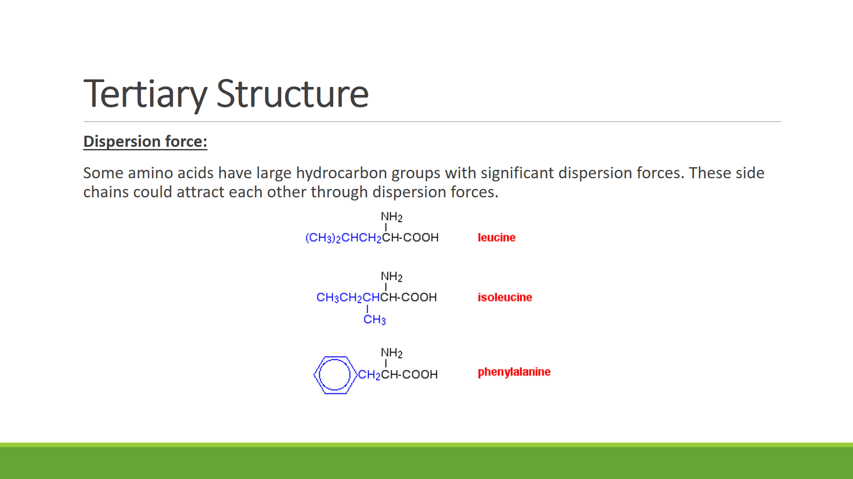

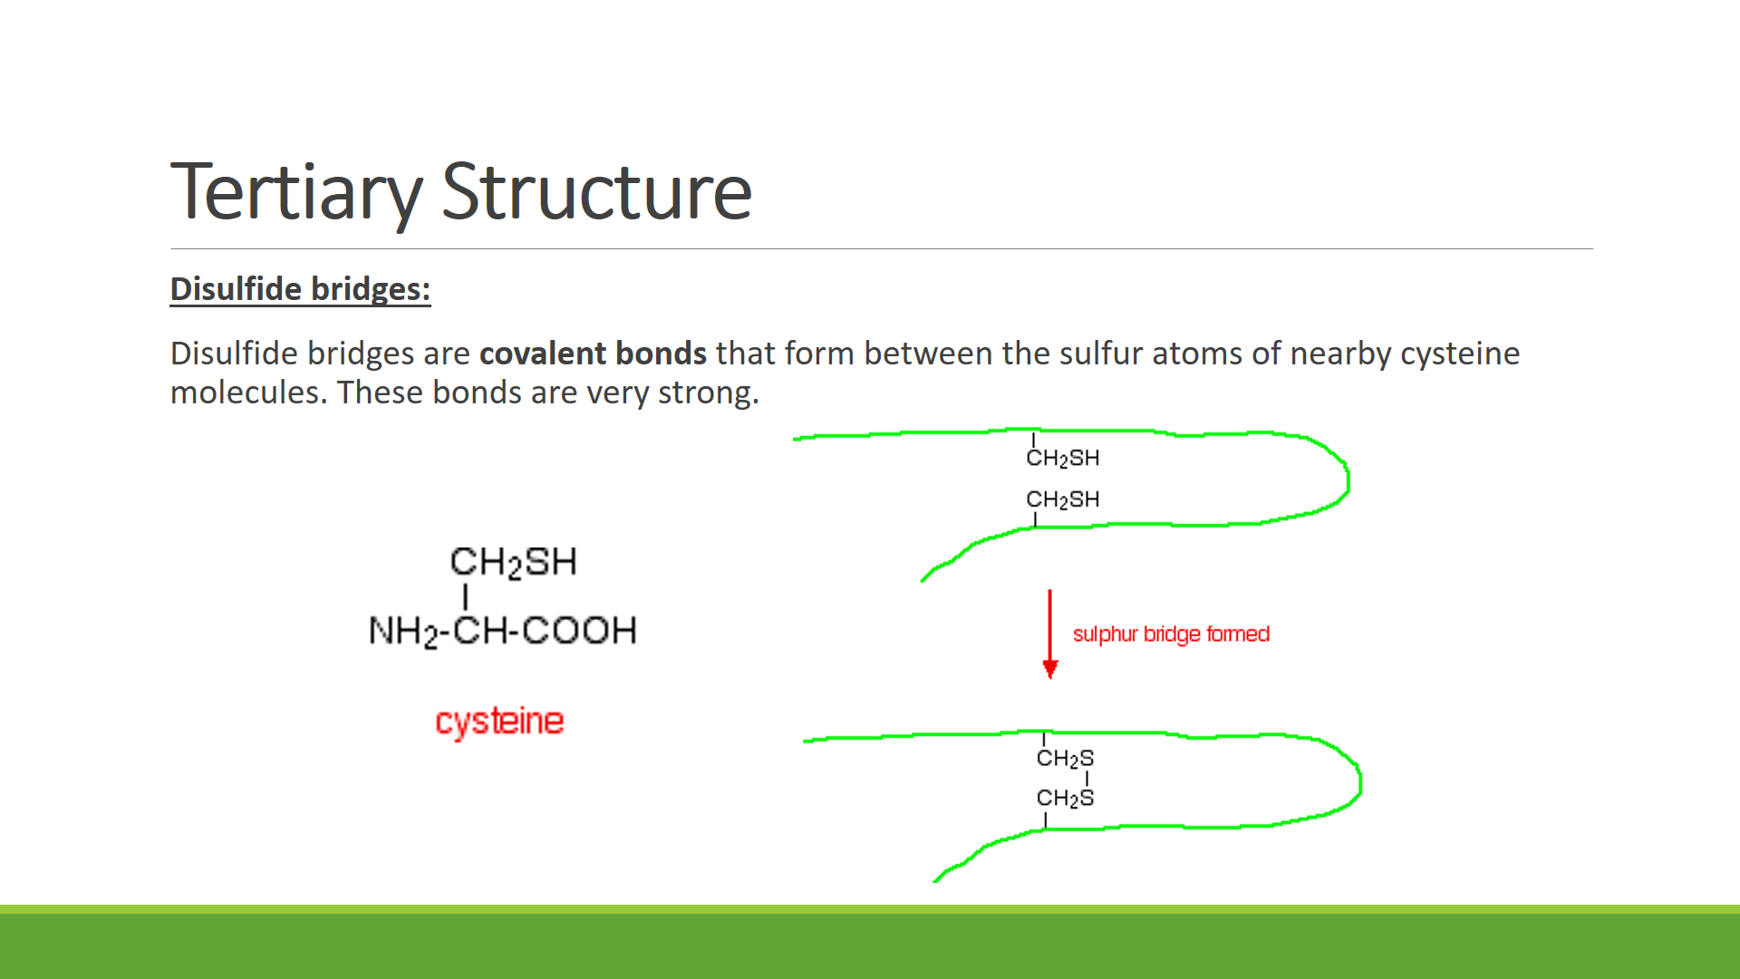

Q: Identify and label four interactions between side-groups that affect the tertiary structure of the below protein

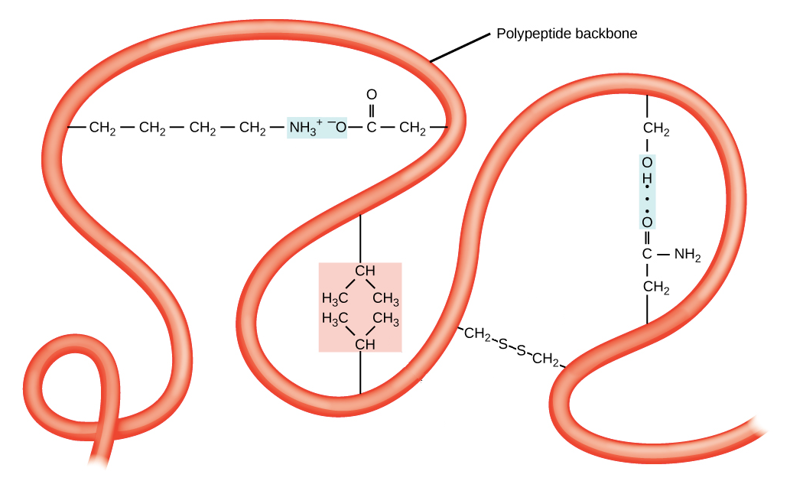

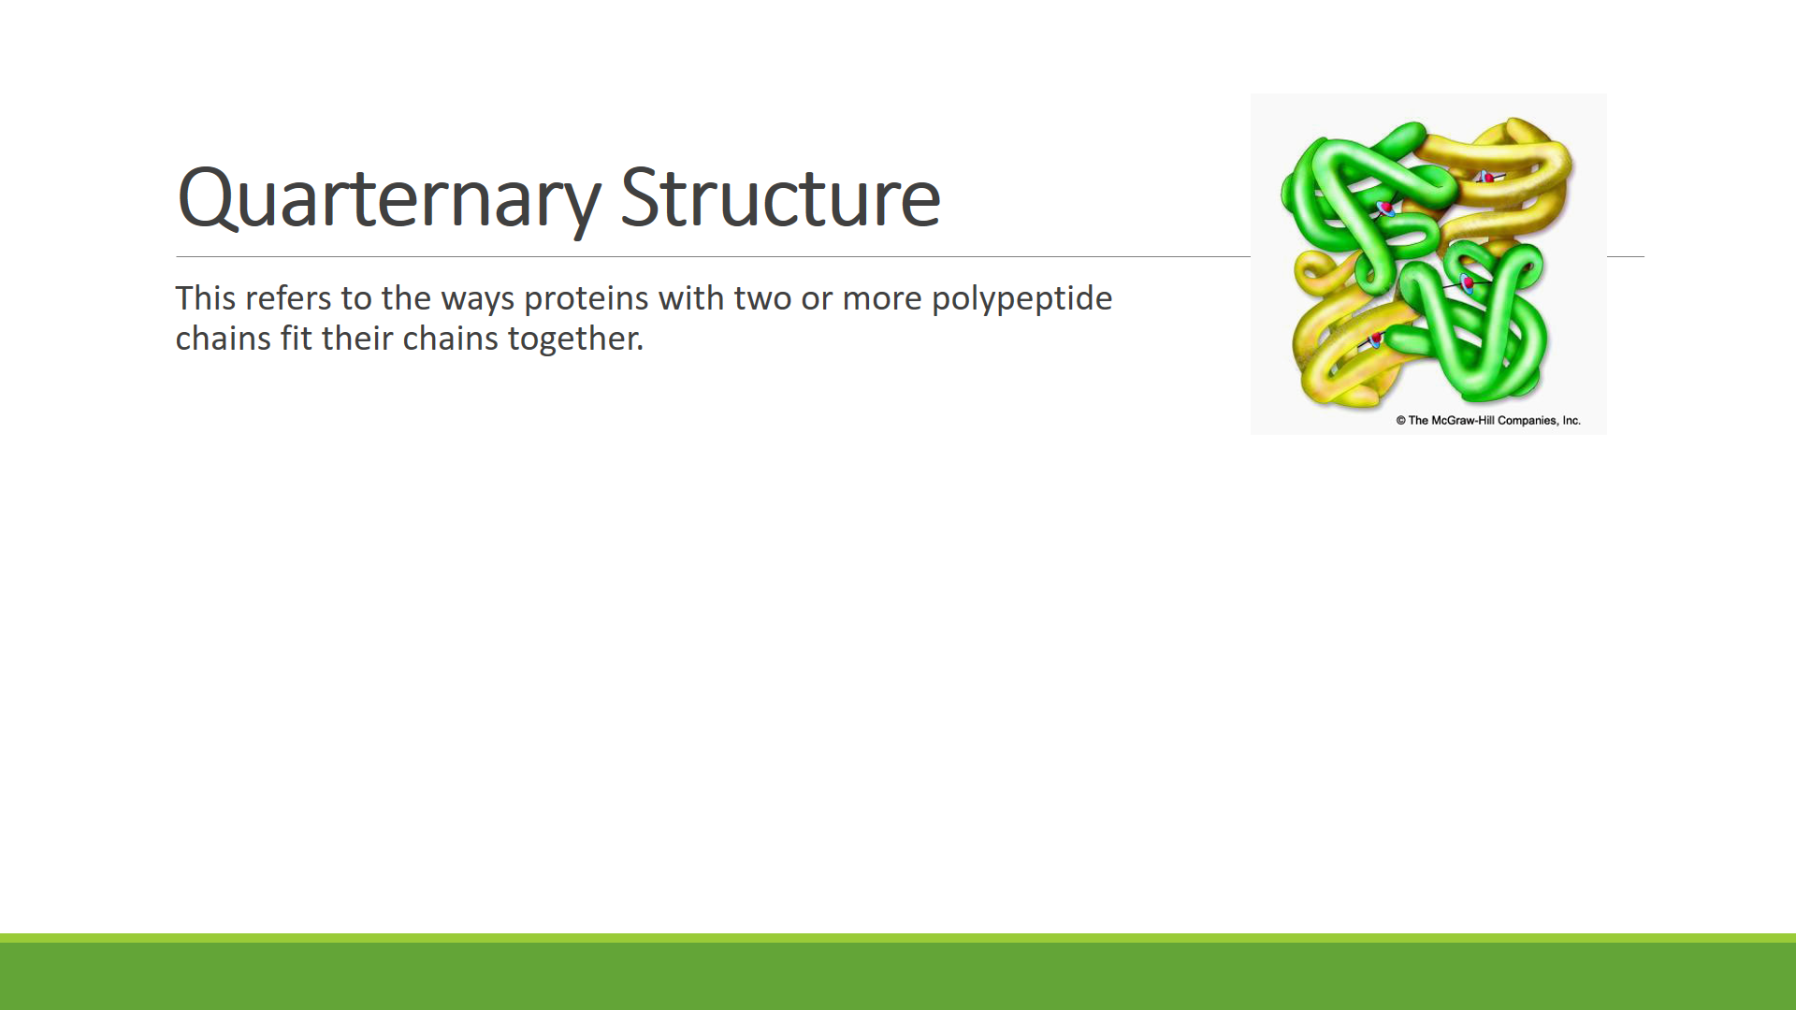

***SUMMARY OF PROTEIN STRUCTURE***

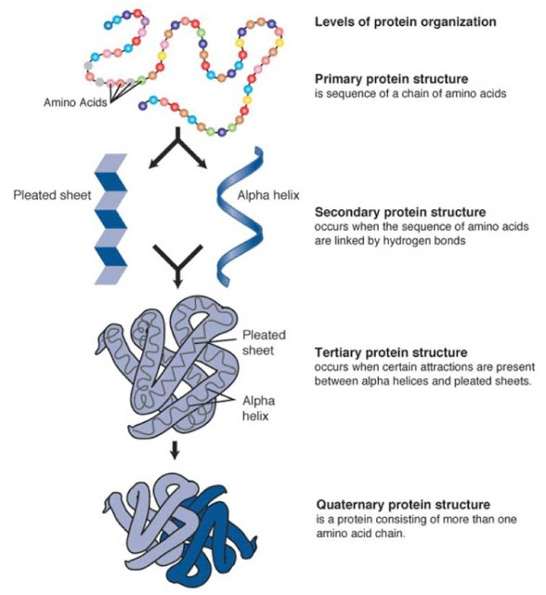

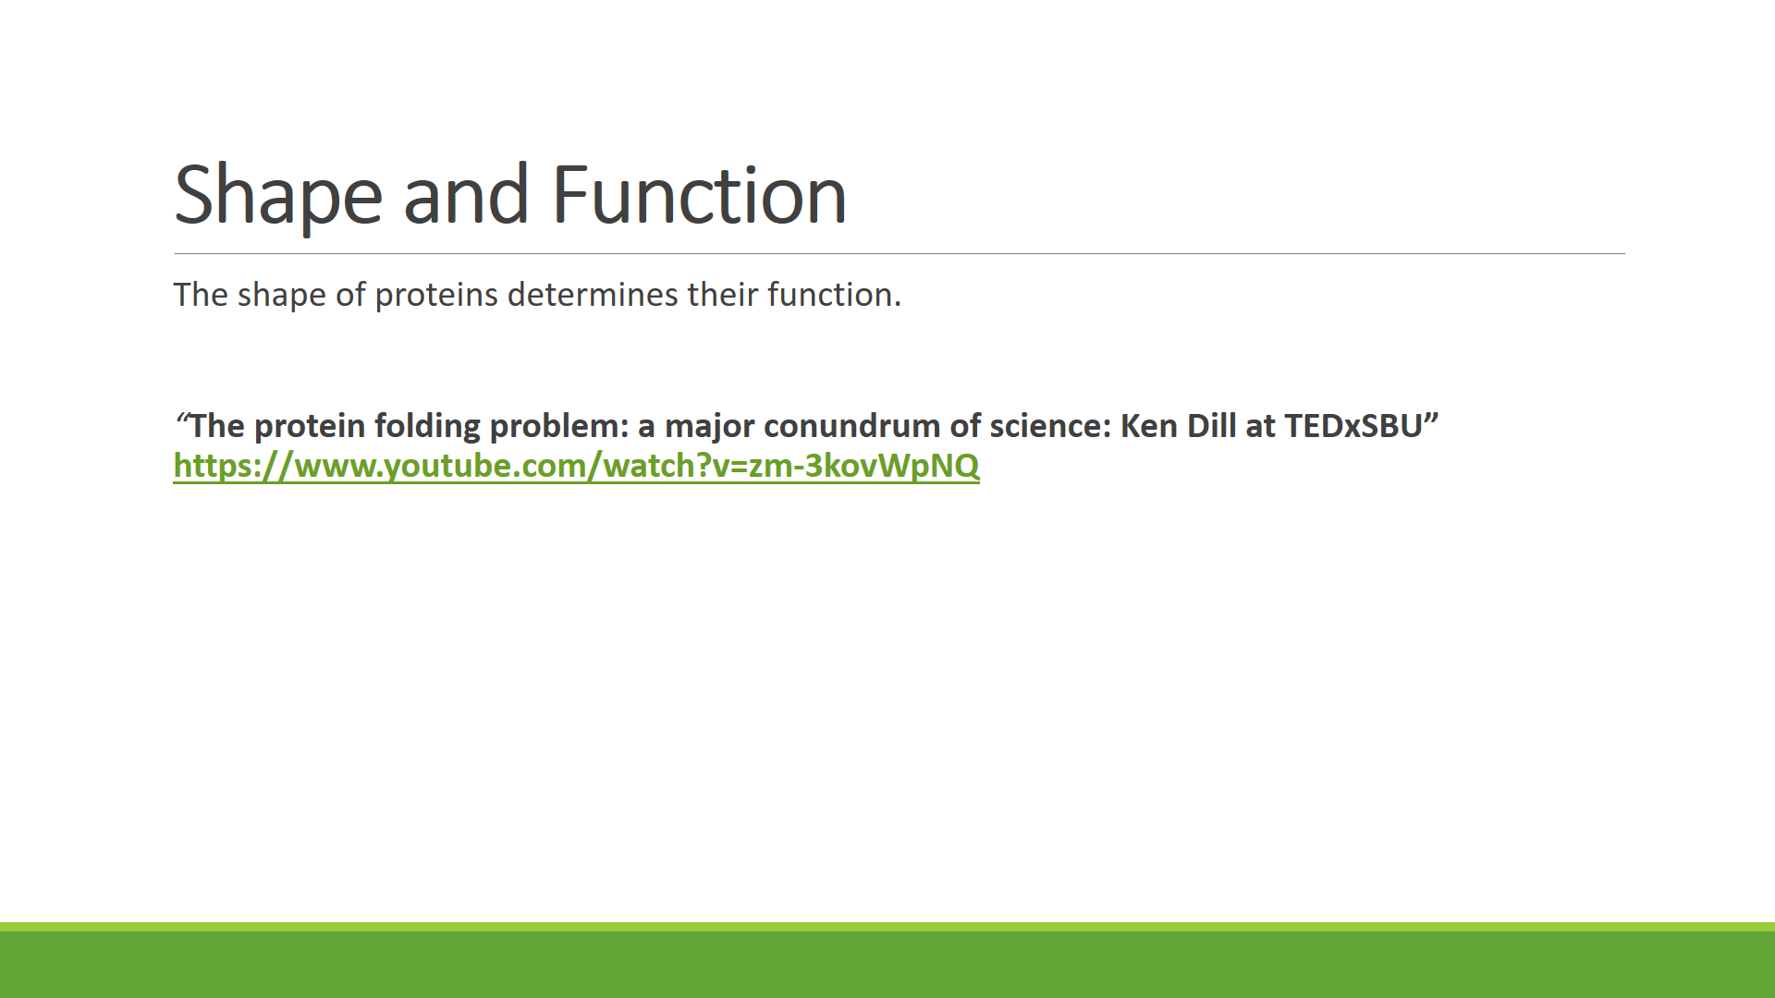

*“***The protein folding problem: a major conundrum of science: Ken Dill at TEDxSBU”** [**https://www.youtube.com/watch?v=zm-3kovWpNQ**](https://www.youtube.com/watch?v=zm-3kovWpNQ)

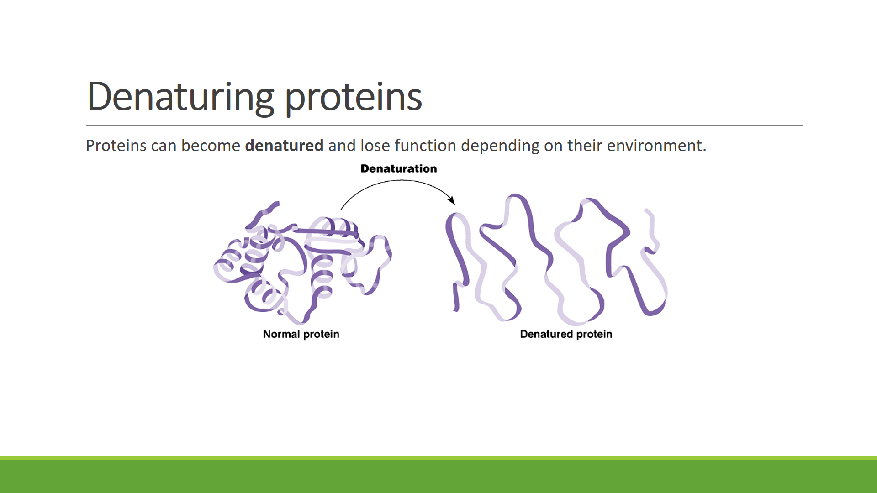

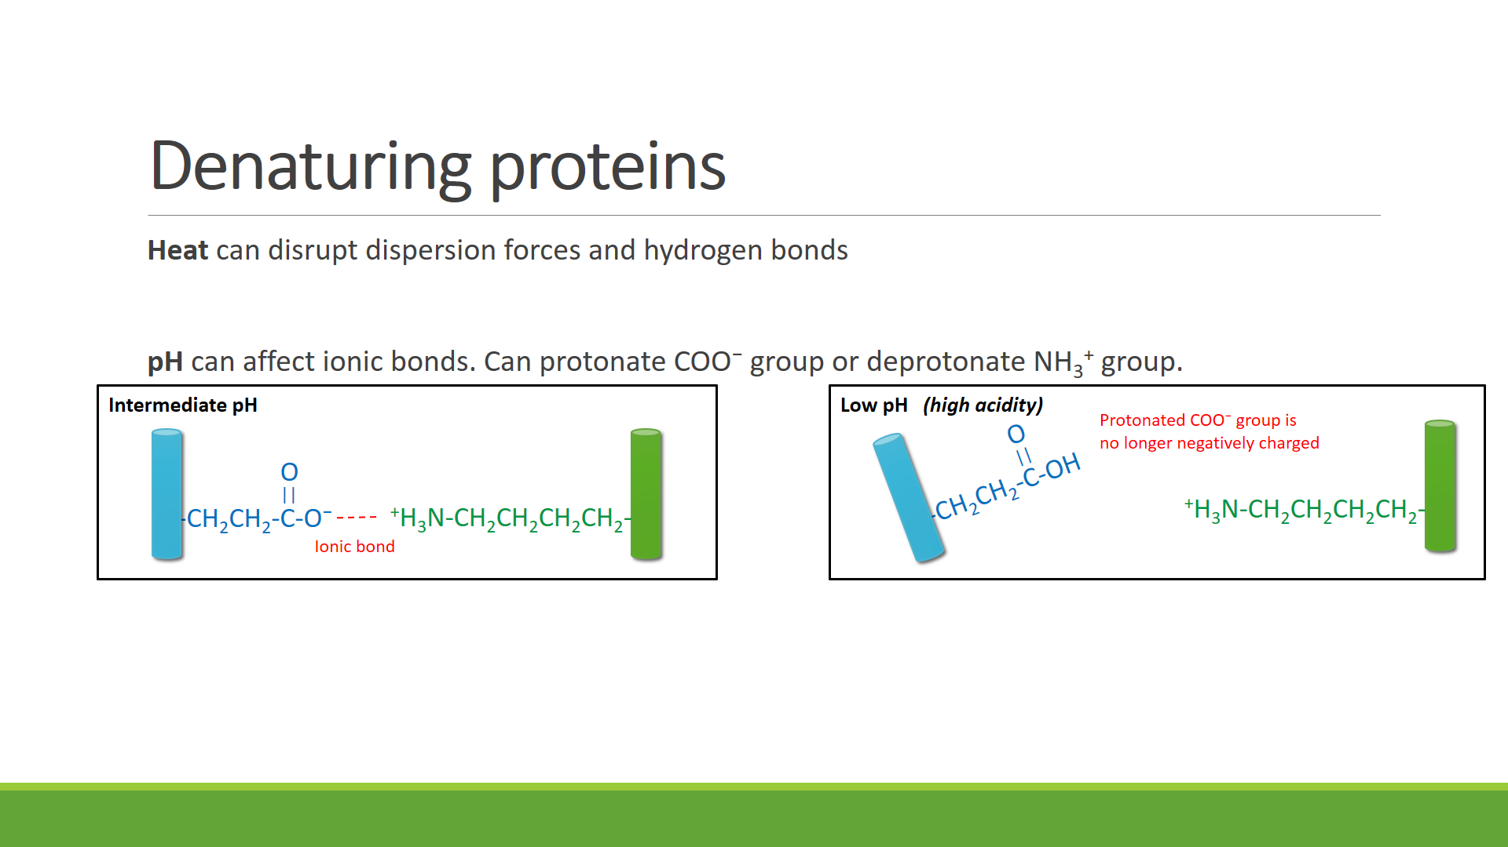

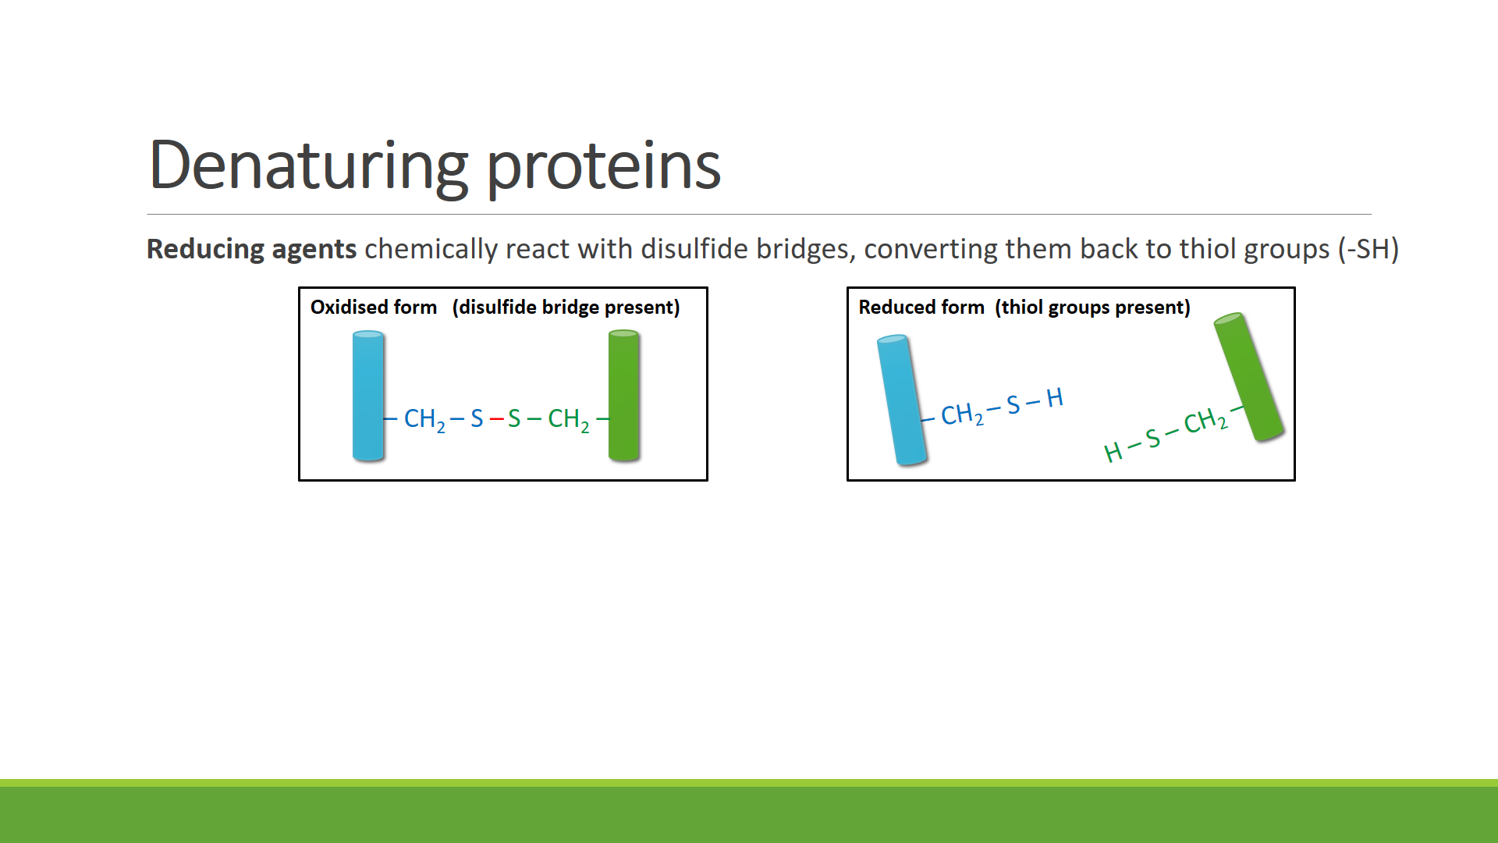

**Protein Data Bank.** Explore the Protein Data Bank (<http://www.rcsb.org/pdb/home/home.do>). What is it? Who uses it?